**1.** You download an Azure resource Manager template based on an existing Virtual

machine. The template will be used to deploy 100 virtual machines. You need to

modify the template to reference an administrative password. You must prevent the

password from being stored in plain text.

What should you create to store the password?

A. Azure Storage account and access policy

B. Azure Key vault and access policy

C. Azure AD identity protection and Azure policy

D. Recovery services vault and backup policy

**2.** You plan to deploy 3 Virtual Machines named VM1, VM2 and VM3. The virtual

machines will host a web app named App1. You need to ensure that at least 2

virtual machines are available if a single Azure data center becomes unavailable.

What should you deploy ?

A. Each virtual machine in a separate availability zone.

B. All three virtual machines in a single availability zone.

C. All Virtual machines in a single availability Set.

D. Each virtual machine in a separate availability Set.

**3.** Your company has virtual machines hosted in Microsoft Azure. The VMs are located

in a single Azure virtual network named VNet1. The company has users that work

remotely. The remote workers require access to the VMs on VNet1. You need to

provide access for the remote workers. What should you do?

A. Configure a Site-to-Site (S2S) VPN

B. Configure a Point-to-Site (P2S) VPN

C. Configure a Multi Site VPN

D. Configure a VNet-to-VNet VPN

**4.** You have an Azure virtual machine VM1 that runs Windows Server 2022. You save

VM1 as a template named Template1 to the Azure Resource Manager library. You

plan to deploy a virtual machine named VM2 from Template1.

Which of the following you need to configure during the deployment of VM2?

(Choose two)

A. Resource Group

B. Operating System

C. Virtual Machine Size

D. Administrator Username

**5.** Your Company wants to share the JSON files stored in a container inside a storage

account. What is the correct url for the file called 'employee_data.json'?

Storage Account :'monthlyreports'

Container: 'may2023'

File: 'employee_data.json'

A. https://employee_data.json

B. https://monthlyreports.blob.core.windows.net/may2023/employee_data.json

C. https://monthlyreports/may2023/employeedata.json

D. https://monthlyreports.blob.core.windows.net/employee_data.json

**6.** A Company needs to connect their on-premise data centers to Azure. They have

huge workloads that need to regularly transfer between on premise data centers

and Azure. The company wants to avoid sending data over the public internet for

security reasons. Which of the following options should the company opt to

establish this connection?

A. Create a Point-to-Site (P2S) Connection

B. Create a Site-to-Site (S2S) Connection

C. Create an ExpressRoute Connection

D. Create a VNet-to-VNet Connection

**7.** Your company wants to move an entire solution to Azure. Due to security

constraints company wants to restrict creation of all resources in a particular region.

Which Azure service can be used to achieve this requirement?

A. Azure Policy

B. Azure Monitor

C. Azure Availability Zone

D. Azure Web Apps

**8.** A company has a Azure subscription which contains resource group named RG1

which is set to Australia East location. RG1 is used to host temporary resources and

contains resources shown below?

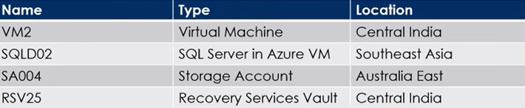

SQLD02 is backed up to RSV25. When a user tries to delete RG1 from Azure Portal,

the deletion fails. What is the first needs to take to ensure a successful deletion?

A. Delete Storage Account SA004

B. Restart VM2

C. Stop backup of SQLD02

D. Stop VM2

**9.** A Company needs to identify idle and underutilized Azure Virtual machines which

can be changed to a less costly service tier. What should the company use?

A. File Storage

B. Azure Advisor

C. Azure Monitor

D. Customer Insights

**10.** You have an Azure subscription named subscription1. You have 5TB of data that

you need to transfer to subscription1. You plan to use Azure Import/Export job.

What can you use as the destination of the imported data?

A. Azure File Storage

B. Azure Data Factory

C. Azure Cosmos DB

D. Azure SQL Database

**11.** Your company has a Microsoft SQL Server Always On availability group

configured on their Azure virtual machines (VMs). You need to configure an

Azure internal load balancer as a listener for the availability group.

Solution: You create an HTTP health probe on port 1433.

Does the solution meet the goal?

A. Yes

B. No

**12.** You have an Azure subscription named subscription1. You have 5TB of data that

you need to transfer to subscription1. You plan to use Azure Import/Export job.

What can you use as the destination of the imported data?

A. Azure Cosmos DB

B. Azure Data Factory

C. Azure Blob storage

D. Azure SQL Database

**13.** Your company has a Microsoft SQL Server Always On availability group

configured on their Azure virtual machines (VMs). You need to configure an

Azure internal load balancer as a listener for the availability group.

Solution: You create an TCP health probe on port 1433.

Does the solution meet the goal?

A. Yes

B. No

**14.** You have an Azure subscription that contains an Azure Storage account and You

plan to copy an on-premises virtual machine image to a container named vmimages. Which command should you run to create the container for the

planned image ?

azcopy 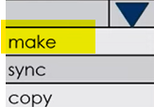

'https://devopshubstorage.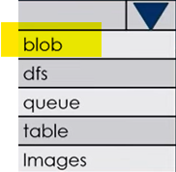. core windows.net/vmimages'

**15.** A company has a requirement to deploy Windows VM in its subscription. Which

CLI command should the administrator run in order to create the Virtual Machine?

A. New-AzVM

B. Create-AzVM

C. New-AzureRmVM

D. az vm create

**16.** Your company has an Azure Active Directory (Azure AD) subscription. You need to deploy five virtual machines (VMs) to your company's virtual network subnet. The VMs will each have both a public and private IP address. Inbound and outbound security rules for all of these virtual machines must be identical. Which of the following is the least amount of network interfaces needed for this configuration?

A. 5

B. 10

C. 20

D. 40

**17.** Your company has a general-purpose v1 Azure Storage account named storage1

that uses locally-redundant storage (LRS). You are tasked with implementing a solution that ensures the data in the storage account is protected if a zone fails. The solution must minimize costs and administrative effort. What should you do first?

A. Configure Object replication rules

B. Create a new storage account

C. Modify the replication settings of the storage account

D. Upgrade the account to general purpose V2

**18.** You have an Azure subscription named Subscription1 that contains the resources

shown in the following table.

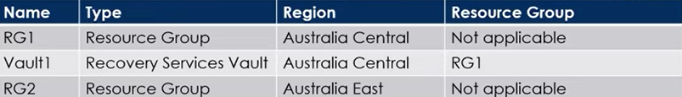

You create virtual machines in Subscription1 as shown in the following table.

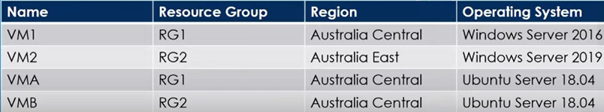

You plan to use Vaulti for the backup of as many virtual machines as possible. Which virtual machines can be backed up to Vault1?

A. VM2 only

B. VM1 and VMA only

C. VM1, VMA and VMB only

D. VM2 and VMB only

**19.** You have an Azure Active Directory tenant named contosocloud.onmicrosoft.com. Your company has a public DNS zone for contoso.com. You add contoso.com as a custom domain name to Azure AD. You need to ensure that Azure can verify the domain name. Which type of DNS record should you create?

A. MX

B. NSEC

C. RRSIG

D. PTR

**20.** You have an Azure subscription that contains an Azure Active Directory tenant

named contoso.com and an Azure Kubernetes Service (AKS) cluster named AKS1. An administrator reports that she is unable to grant access to AKS1 to the users in contoso.com. You need to ensure that access to AKS1 can be granted to the contoso.com users. What should you do first?

A. From contoso.com, create an OAuth 2.0 authorization endpoint.

B. From contoso.com, modify the Organization relationships settings.

C. Recreate AKS1

D. From AKS1, create a namespace.

**21.** Your organization's system administrator has deployed two standalone Azure

Virtual Machines for a new web service. You now want to add these virtual machines to fault domains in an availability set. When you attempt to do this in the portal, you receive an error message preventing you from completing the task. What is the reason for this?

A. The availability set has to be paused or stopped before Standalone VMs can be

added.

B. VMs Operating system is not compatible with fault domains

C. You didn't check the required "Standalone" parameter in Azure Portal

D. You can't add running Standalone VMs to availability sets.

**22.** Which Azure tool is a cloud based command line service for copying and migrating data between Azure Storage accounts?

A. Import/Export Service

B. AzCopy

C. Azure Data Box

D. Azure Storage Explorer

**23.** You Suspect hackers and bots have been attacking your applications network.

What Azure network monitoring or analysis tool would best fit your needs?

A. Security Group View

B. Network Performance monitor

C. Connection monitor

D. Traffic Analysis

**24.** You have an Azure subscription that contains the following users in an Azure AD

tenant named contoso.onmicrosoft.com?

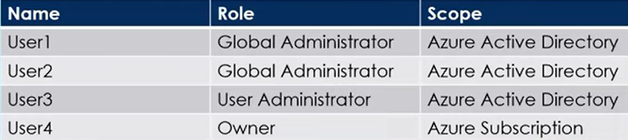

User1 creates a new Azure AD tenant named external contoso.onmicrosoft.com

You need to create new user accounts in external.contoso.onmicrosoft.com

Solution : You instruct User1 to create the user accounts.

Does the solution meet the goal?

A. Yes

B. No

**25.** Your company has a Microsoft Azure Subscription. The company has data centers in Los Angeles and New York, and you are configuring the two data centers as geo-clustered sites for site resiliency. You need to recommend an Azure storage redundancy option which fulfills the following data storage requirements.

* Data must be stored on multiple nodes.
* Data must be stored on nodes in separate geographic locations.
* Data can be read from the secondary location as well as from the Primary location.

Which of the following options should you recommend?

A. Read only geo redundant Storage

B. Zone redundant Storage

C. Locally redundant Storage

D. Geo redundant Storage

**26.** Your company has three virtual machines that are included in an availability set. You try to resize one of the VMs which returns an allocation failure message.

Which of the following actions should you take to resize the VM?

A. You should stop the VM

B. You should stop the other two VMs

C. You should stop all three VMs

D. You should remove the necessary VM from the availability set.

**27.** You create an Azure storage account named contosostorage. You plan to create a file share named data. Users need to map a drive from their home computers that run windows 11 to the data file share. Which outbound port should you open between the home computer and data file share?

A. 80

B. 443

C. 445

D. 3389

**28.** When using Azure resource manager (ARM) templates, what feature enables you to control resource properties during deployment in your organization?

A. Active Directory

B. Azure Policy

C. API Management

D. Resource tags

**29.** You have an Azure Subscription that contains a resource group named RG1. You plan to use an ARM template named template1 to deploy resources and the solution must meet following requirements.

* Deploy new resources to RG1
* Remove all the existing resources from RG1 before deploying the new resources.

Select the appropriate options to complete the command.

New-AzResourceGroupDeployment -TemplateUri "https://contoso.com/template1"

-TemplateParameterFile params.json 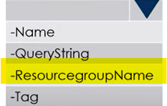 RG1-Mode 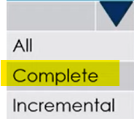

**30.** Your company has an Azure subscription. You need to deploy a number of Azure virtual machines (VMs) using Azure Resource Manager (ARM) templates. You have been informed that the VMs will be included in a single availability set. You are required to make sure that the ARM template you configure allows for as many VMs as possible to remain accessible in the event of fabric failure or maintenance. Which of the following is the value that you should configure for the platformUpdateDomainCount property?

A. 10

B. 20

C. 30

D. 40

**31.** Which Azure Storage service is designed for large-scale, offline data migration intended to help businesses migrate their data onto the Azure Cloud?

A. StorSimple

B. AzCopy

C. Azure Storage Explorer

D. Azure Data Box

**32.** You plan to deploy several Azure Virtual machines that will run Windows server 2022 in a virtual machine scale set by using ARM template. You need to ensure that NGINX is available on all the virtual machines after they are deployed. What should you use?

A. A Microsoft Intune device configuration profile

B. Deployment Center in Azure App Service.

C. A Desired State Configuration (DSC) extension

D. The New-AzConfigurationAssignment cmdlet

**33.** You have an on-premises file server named Server1 that runs Windows Server 2016. You have an Azure subscription that contains an Azure file share. You deploy an Azure File Sync Storage Sync Service, and you create a sync group. You need to synchronize files from Server1 to Azure. Which four actions should you perform in sequence? To answer move the appropriate actions from the list of actions to the answer area and arrange in correct order.

Actions Answer Area

Install the Azure File Sync agent

on Server1.

Install the DFS replication server

role on Server1.

Create a sync group and a Cloud

endpoint.

Create a Recovery services vault.

Register Server1.

Add a Server endpoint.

**34.** You have an Azure subscription that contains the storage accounts shown in the

following table.

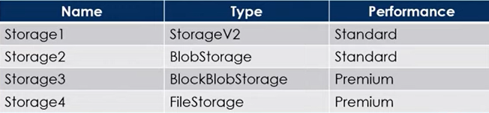

You plan to manage the data stored in the accounts by using lifecycle management

rules. To which storage accounts can you apply lifecycle management rules?

A. storage1 only

B. storage1 and storage2 only

C.storage3 and storage4 only

D. storage1, storage2 and storage3 only

E. storage1, storage2 , storage3 and storage4.

<https://learn.microsoft.com/en-us/azure/storage/blobs/lifecycle-management-overview>

**35.** Your company has a Microsoft SQL Server Always On availability group configured on their Azure virtual machines (VMs). You need to configure an Azure internal load balancer as a listener for the availability group.

**Solution:** You enable Floating IP.

Does the solution meet the goal?

A. Yes

B. No

<https://learn.microsoft.com/en-us/azure/azure-sql/virtual-machines/windows/availability-group-load-balancer-portal-configure?view=azuresql>

**36.** You plan to track resource usage and prevent the deletion of resources. To which resources can you apply locks and tags? To answer, select appropriate options in the answer area.

Locks: 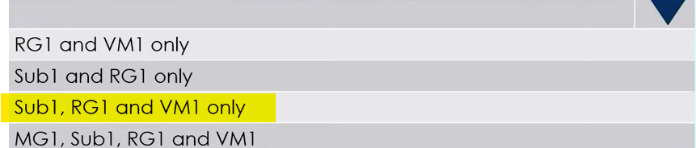

Tags: 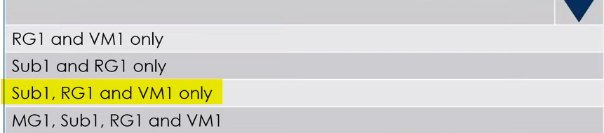

**37.** You have a computer named Computer1 that has a point-to-site VPN connection to an Azure virtual network named VNet1. The point-to-site connection uses a self-signed certificate. From Azure, you download and install the VPN client configuration package on a computer named Computer2. You need to ensure that you can establish a point-to-site VPN connection to VNet1 from Computer2.

**Solution:** You modify the Azure Active Directory (Azure AD) authentication policies.

Does the solution meet the goal?

A. Yes

B. No

**38.** You have an Azure subscription named Subscription1 that contains a virtual network named VNet1. VNet1 is in a resource group named RG1. Subscription1 has a user named User1. User1 has the following roles:

* Reader
* Security Admin
* Security Reader

You need to ensure that User1 can assign the Reader role for VNet1 to other users.

What should you do?

A. Assign User1 the Network Contributor role for VNet1.

B. Assign User1 the Owner role for VNet1.

C. Remove User1 from the Security Reader role for Subscription1. Assign User1 the

Contributor role for RG1.

D. Assign User1 the Contributor role for VNet1.

<https://learn.microsoft.com/en-us/azure/role-based-access-control/built-in-roles>

**39.** You have an Azure Active Directory (Azure AD) tenant named contoso.com. You have a CSV file that contains the names and email addresses of 500 external users. You need to create a guest user account in contoso.com for each of the 500 external users.

**Solution:** From Azure AD in the Azure portal, you use the Bulk create user operation.

Does this meet the goal?

A. Yes

B. No

**40.** You plan to automate the deployment of a virtual machine scale set that uses the Windows Server 2016 Datacenter image. You need to ensure that when the scale set virtual machines are provisioned, they have web server components installed.

Which two actions should you perform?

A. Create an automation account.

B. Upload a configuration script

C. Create an Azure policy

D. Modify the ExtensionProfile section of the Azure Resource Manager template

E. Create a new virtual machine scale set in the Azure portal

**41.** You have an Azure virtual machine named VM1 that runs Windows Server 2019. You need to create an alert in Azure when more than two error events are logged to the System event log on VM1 within an hour.

**Solution:** You create an event subscription on VM1. You create an alert in Azure Monitor and specify VM1 as the source.

Does this meet the goal?

A. Yes

B. No

<https://learn.microsoft.com/en-us/azure/azure-monitor/agents/agents-overview>

**42.** You have an Azure subscription named Subscription1 that contains an Azure Log Analytics workspace named Workspace1. You need to view the error events from a table named Event. Which query should you run in Workspace1?

A. search in (Event) * | where EventType eq "error"

B. select * from Event where EventType == "error"

C. Event | search "error"

D. Get-Event Event | where {$ _. EventType == "error"}

<https://learn.microsoft.com/en-us/azure/data-explorer/kusto/query/search-operator#search-predicate-syntax>

**43.** Your company has two on-premises servers named SRV01 and SRV02. Developers have created an application that runs on SRV01. The application calls a service on SRV02 by IP address. You plan to migrate the application on Azure virtual machines. You have configured two VMs on a single subnet in an Azure virtual network. You need to configure the two VMs with static internal IP addresses.

What should you do?

A. Modify the IP properties in Windows Network and Sharing Center.

B. Run the Set-AzureStaticVNetIP PowerShell cmdlet.

C. Modify the VM properties in the Azure Management Portal.

D. Run the New-AzureRMVMConfig PowerShell cmdlet.

E. Run the Set-AzureSubnet PowerShell cmdlet

**44.** You have an Azure subscription named Subscription1. You create an Azure Storage account named contosostorage, and then you create a file share named data. Which UNC path should you include in a script that references files from the data file share? To answer, drag the appropriate values to the correct targets. Each value may be used once, more than once or not at all?

|  |  |
| --- | --- |
| Values | Answer area |
| blob  contosostorage  file.core.windows.net  data  blob.core.windows.net | \\ . \  data  file.core.windows.net  contosostorage |

**45.** Your company has an Azure Active Directory (Azure AD) tenant that is configured for hybrid coexistence with the on-premises Active Directory domain. The on-premise virtual environment consists of virtual machines running on Windows Server 2012 R2 Hyper-V host servers. You have created some PowerShell scripts to automate the configuration of newly created VMs. You plan to create several new VMs and need a solution that ensures the scripts are run on the new VMs. Which of the following is the best solution?

A. Place the scripts in a new virtual hard disk (VHD).

B. Configure a Group Policy Object (GPO) to run the scripts as startup scripts.

C. Configure a SetupComplete.cmd batch file in the %windir%\setup\scripts directory.

D. Configure a Group Policy Object (GPO) to run the scripts as logon scripts.

**46.** You have an Azure Directory tenant named DevOpsHub and an Azure Subscription named Subscription1. DevOpsHub contains a group named Developers. Subscription1 contains a resource group named Dev. You need to provide the Developers group with the ability to create Azure logic apps in the Dev resource group.

**Solution:** On Subscription1, you assign the Logic App Operator role to the Developers group.

Does this meet the goal?

A. Yes

B. No

**47.** Your company has an Azure Active Directory (Azure AD) tenant that is configured for hybrid coexistence with the on-premises Active Directory domain. You plan to deploy several new virtual machines in Azure. The VMs will have the same operating system and custom software requirements. You configure a reference VM in the on-premise virtual environment. You then generalize the VM to create an image. You need to upload the image to Azure to ensure that it is available for selection when you create the new Azure VMs. Which PowerShell cmdlets should you use?

A. Add-AzlmageDataDisk

B. Add-Azlmage

C. Add-AzVhd

D. Add-AzVM

**48.** You have an Azure policy as shown in the following exhibit What is the effect of the policy?

A. You can create Azure SQL servers in contosoRG1 only

B. You are prevented from creating azure SQL Servers in ContosoRG1

only.

C. You can create Azure SQL servers in any resource group within Subscription.

D. You are prevented from creating Azure SQL servers anywhere in Subscription 1.

**49.** You have an Azure AD tenant named devopshub.com that contains the groups

shown in the table on the left. devopshub.com contains the users shown in the table on the right.

|  |  |
| --- | --- |
|  |  |

You assign the Azure Active Directory Premium Plan 2 license to Group1 and User4. Which users are assigned the Azure Active Directory Premium Plan 2 license?

1. User1, User2 and User4 only.
2. User 4 only.
3. User1 and User4 only.
4. User1, User2, User3 and User4.

**49.** Your company has an azure subscription that includes a storage account, a resource group, a blob container, and a file share. A colleague named Jim Taylor makes use of a solitary Azure Resource Manager (ARM) template to deploy a virtual machine and an additional Azure Storage account. You want to review the ARM template that was used by Jim Taylor.

**Solution:** You access the Resource Group blade.

Does the solution meet the goal?

A. Yes

B. No

**50.** You have an Azure subscription named Subscription1 and an on-premises deployment of Microsoft System Center Service Manager. Subscription1 contains virtual machine named VM1. You need to ensure that an alert is set in Service Manager when the amount of available memory on VM1 is below 10 percent.

What should you do first?

A. Deploy a function app.

B. Create an automation runbook.

C. Create a notification.

D. Deploy the IT Service Management Connector (ITSM)

**51.** You have three offices and an Azure subscription that contains an Azure Active Directory (Azure AD) tenant. You need to grant user management permissions to a local administrator in each office. What should you use?

A. Access packages in Azure AD entitlement management

B. Azure roles

C. Administrative units

D. Azure AD roles

**52.** You have an Azure subscription named Subscription1. Subscription1 contains the resource groups in the following table.

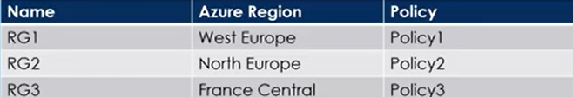

RG1 has a web app named WebApp1. WebApp1 is located in West Europe.

You move WebApp1 to RG2. What is the effect of the move?

A. The App Service plan for WebApp1 moves to North Europe. Policy1 applies to WebApp1.

B. The App Service plan for WebApp1 remains in West Europe. Policy2 applies to WebApp1.

C. The App Service plan for WebApp1 moves to North Europe. Policy2 applies to WebApp1.

D. The App Service plan for WebApp1 remains in West Europe. Policy1 applies to WebApp1.

**53.** You have an Azure virtual machine named VM1 that runs Windows Server 2019. The VM was deployed using default drive settings. You sign in to VM1 as a user named User1 and perform the following actions:

* Create files on drive C.
* Create files on drive D.
* Modify the screen saver timeout.
* Change the desktop background.

You plan to redeploy VM1. Which changes will be lost after you redeploy VM1?

A. The new files on drive C

B. The new desktop background

C. The modified screen saver timeout

D. The new files on drive D

**54.** You deploy an Azure Kubernetes Service (AKS) cluster named Cluster1 that uses the IP addresses shown in the following table.

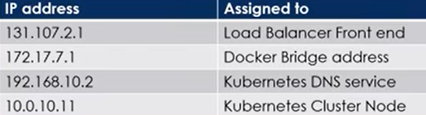

You need to provide internet users with access to the applications that run in Cluster1. Which IP address should you include in the DNS record for Cluster1?

A. 192.168.10.2

B. 172.17.7.1

C. 131.107.2.1

D. 10.0.10.11

**55.** You have an Azure subscription linked to an Azure Active Directory tenant. The tenant includes a user account named User1. You need to ensure that User1 can assign a policy to the tenant root management group.

What should you do?

A. Assign the Global administrator role to User1, and then instruct User1 to configure access management for Azure resources.

B. Create a new management group and delegate User1 as the owner of the new management group.

C. Assign the Owner role for the Azure subscription to User1, and then instruct to configure access management for Azure resources.

D. Assign the Owner role for the Azure Subscription to User1, and then modify the default conditional access policies.

**56.**  You have an Azure Storage account named storage1 that uses Azure Blob storage and Azure File storage. You need to use AzCopy to copy data to the blob storage and file storage in storage1. Which authentication method should you use for each type of storage?

To answer, select the appropriate options in the answer area.

Blob Storage: 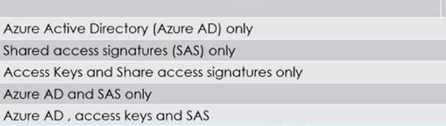

File storage: 

**57.** You have an Azure subscription linked to an Azure Active Directory tenant. The tenant includes a user account named User1. You need to ensure that User1 can assign a policy to the tenant root management group. What should you do?

A. Assign the Global administrator role to User1, and then instruct User1 to configure access management for Azure resources.

B. Create a new management group and delegate User1 as the owner of the new management group.

C. Assign the Owner role for the Azure subscription to User1, and then instruct User1 to configure access management for Azure resources.

D. Assign the Owner role for the Azure Subscription to User1, and then modify the default conditional access policies.

**58.** You have an Azure subscription that contains a virtual machine named VM1. VM1 hosts a line-of-business application that is available 24 hours a day. VM1 has one network interface and one managed disk. VM1 uses the Dsv3 size.

You plan to make the following changes to VM1:

* Change the size to Dpsv5.
* Add a 500-GB managed disk.
* Add the Puppet Agent extension.
* Enable Desired State Configuration Management.

Which change will cause downtime for VM1?

A. Add the Puppet Agent extension

B. Add a 500-GB managed disk

C. Change the size to Dpsv5

D. Enable Desired State Configuration Management

**59.** You have an Azure subscription that contains a web app named webapp1. You need to add a custom domain named www.contoso.com to webapp1.

What should you do first?

A. Create a DNS record.

B. Upload a certificate.

C. Add a connection string.

D. Stop webapp1.

**60.** You deploy an Azure Kubernetes Service (AKS) cluster named AKS1. You need to deploy a YAML file to AKS1.

**Solution:** From Azure CLI, you run the kubectl client.

Does this meet the goal?

A. Yes

B. No

**61.** You have an Azure subscription that contains a Azure Kubernetes Service (AKS) cluster named AKS1. The autoscaling feature is enabled. You need to configure the minimum and maximum node counts for AKS1. Which cmdlet should you use?

A. Set-AzAksCluster

B. Start-AzAksCluster

C. Update-AzAksNodePool

D. Set-AzAksClusterCredential

**62.** You have an Azure subscription that contains a Azure Container app named containerapp1. You plan to add scaling rules to containerapp1. You need to ensure that containerapp1 replicas are created based on received messages in the Azure service bus. Which scale trigger should you use?

A. HTTP driven

B. Event driven

C. Memory Usage

D. CPU Usage

<https://learn.microsoft.com/en-us/azure/container-apps/scale-app?pivots=azure-cli>

**63.** You have an Azure subscription that contains two Log Analytics workspaces name Workspace1 and Workspace2 and 100 virtual machines that run Windows Server. You need to collect performance data and events from the virtual machines. The solution must meet the following requirements:

* Logs must be sent to Workspace1 and Workspace 2.
* All Windows events must be captured.
* All security events must be captured.

What should you install and configure on each virtual machine?

A. Windows Azure diagnostics extension (WAD)

B. Azure Monitor agent

C. Windows VM agent

**64.** You have an Azure subscription that uses the public IP addresses shown in the

following table.

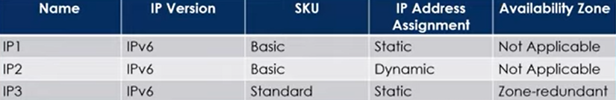

You need to create a public Azure Standard Load Balancer. Which public IP addresses can you use?

1. IP2 only
2. IP3 only
3. IP1 and IP3 only
4. IP1, IP2 and IP3

**65.** Your company has a series of virtual machines created as part of their Azure subscription. They want to ensure the IT administrative team is notified if any of the virtual machines go into the "deallocated" state. Which of the following could you perform to fulfill this requirement?

A. Enable Diagnostics logs for the virtual machine.

B. Create an alert based on the Activity log for the virtual machine.

C. Assign a resource tag for the virtual machine and then create an alert based on that resource tag.

D. Create an Azure policy using an in-built definition from the compute category.

**66.** Your company has an azure subscription that includes a storage account, a resourcegroup, a blob container and a file share. A colleague named Jim Taylor makes useof a solitary Azure Resource Manager (ARM) template to deploy a virtual machineand an additional Azure Storage account. You want to review the ARM templatethat was used by Jim Taylor.

**Solution:** You access the Virtual Machine blade.

Does the solution meet the goal?

A. Yes

B. No

**67.** Your company has an Azure Active Directory (Azure AD) tenant named devopshub2023.com. Company has appointed User1 to review all the settings of the tenant. As an admin your job is to ensure that the User1 can review all the settings of the tenant however User1 must be prevented from changing any settings. Which role should you assign to User1?

A. Security reader

B. Directory reader.

C. Global reader

D. Reports reader

**68.** You have an Azure Active Directory (Azure AD) tenant namedcontoso.onmicrosoft.com that contains 100 user accounts. You purchase 20 AzureAD Premium P2 licenses for the tenant. You need to ensure that 20 users can useall the Azure AD Premium features. What should you do?

A. From the Licenses blade of Azure AD, assign a license.

B. From the Directory role blade of each user, modify the directory role.

C. From the Azure AD domain, add an enterprise application.

D. From the Groups blade of each user, invite the users to a group.

**69.** You have a sync group named Sync1 that has a cloud endpoint. The cloud endpoint includes a file named File1.txt. Your on-premises network contains servers that run Windows Server 2019. The servers are configured as shown in the following table.

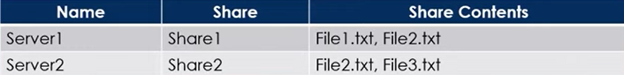

You add Share1 as an endpoint for Sync1. One hour later, you add Share2 as an

endpoint for Sync1. For each of the following statements, select Yes if the

statement is true. Otherwise, select No.

**Statement1 :** On the cloud endpoint, File1.txt is overwritten by File1.txt from Share 1

1. Yes
2. No

**Statement2 :** On Server1, File1.txt is overwritten by File1.txt from Cloud endpoint.

1. Yes
2. No

**Statement3 :** File1.txt from Share1 replicates to Share2

1. Yes
2. No

**70.** Development team for your Project asks you to provision an Azure storage accountfor their use. To remain in compliance with IT security policy, you need to ensurethat the new Azure storage account meets the following requirements:

* Data must be encrypted at rest.
* Access keys must facilitate automatic rotation.
* The company must manage the access keys.

What should you do?

A. Create a service endpoint between the storage account and a virtual network (VNet).

B. Require secure transfer for the storage account.

C. Enable Storage Service Encryption (SSE) on the storage account.

D. Configure the storage account to store its keys in Azure Key Vault.

**71.** You have an Azure subscription that contains the following resources:

* 120 Azure virtual machines
* 20 Azure SQL databases
* 50 Azure file shares

You need to create a daily backup of all the resources by using Azure Backup. What is the minimum number of backup policies that you must create?

A. 1

B. 2

C. 3

D. 150

E. 170

**72.** You have an Azure subscription that has a Recovery Services vault named Vault1.

The subscription contains the virtual machines shown in the following table:

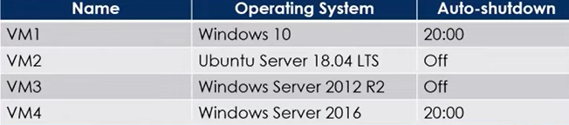

You plan to schedule backups to occur every night at 23:00. Which virtual machines can you back up by using Azure Backup?

A. VM1 only

B. VM1 and VM2 only

C. VM1 and VM3 onlv

D. VM1, VM2, VM3 and VM4

**73.** You administer a solution in Azure that is currently having performance issues. You need to find the cause of the performance issues pertaining to metrics on the Azure infrastructure. Which of the following is the tool you should use to analyze the performance issues?

A. Azure Monitor

B. Azure Activity Log

C. Azure Traffic Analytics

D. Azure Advisor

**74.** You have an Azure subscription named Subscription1 that contains a resource group named RG1. In RG1, you create an internal load balancer named LB1 and a public load balancer named LB2. You need to ensure that an administrator named Admin1 can manage LB1 and LB2. The solution must follow the principle of least privilege. Which role should you assign to Admin1 for each task?

To add a backend pool to LB1: 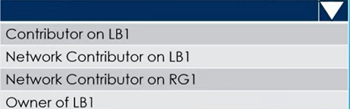

To add a health probe to LB2: 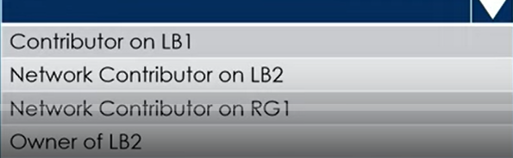

Network Contributer on RG1.

**75.** You have an Azure DNS zone named devopshub.com. You need to delegate a subdomain named cicd.devopshub.com to a different DNS server in Azure.

What should you do?

A. Create a PTR record named cicd in the devopshub.com zone

B. Create a NS record named cicd in the devopshub.com zone

C. Create an A record named *. cicd in the devopshub.com zone

D. Modify the SOA record of devopshub.com

**76.** You have an Azure subscription named Sub1 that contains the Azure resources

shown in the following table.

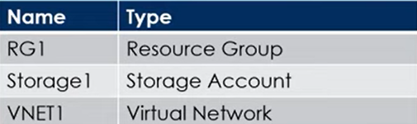

You assign an Azure policy that has the following settings:

* Scope : Sub1
* Exclusions : Sub1/RG1/VNET1
* Policy Definition : Append a tag and its value to resources
* Policy enforcement : Enabled
* Tag name : Tag4
* Tag value : value4

You assign tags to the resources as shown in the following table

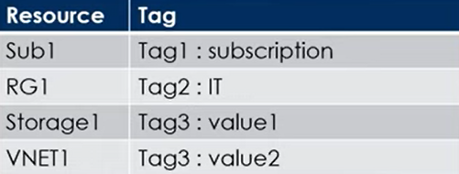

For each of the following statements, select Yes if the statement is true. Otherwise,

select No.

|  |  |
| --- | --- |
| Statements | Yes/No |
| RG1 has the Tag2:IT tag assigned only | Yes |
| Storage1 has the Tag1:subscription, Tag2:IT,  Tag3:value1 and Tag4:value4 tags assigned | No |
| VNET1 has Tag2:IT and Tag3:value2 tags assigned | No |

**77**. You have a hybrid deployment of Azure Active Directory (Azure AD) that contains

the users shown in the following table

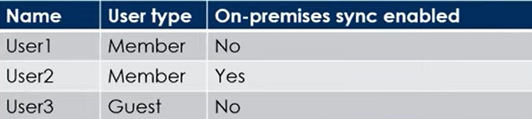

You need to modify the 'JobTitle' and 'UsageLocation' attributes for the users. For

which users can you modify the attributes from Azure AD?

|  |  |
| --- | --- |
| **Job Title** | **UsageLocation** |
|  |  |

**78.** You have an Azure Storage account named storage1. You have an Azure App Service app named App1 and an app named App2 that runs in an Azure container instance. Each app uses a managed identity. You need to ensure that App1 and App2 can read blobs from storage1. The solution must meet the following requirements:

* Minimize the number of secrets used.
* Ensure that App2 can only read from storage1 for the next 30 days.
* What should you configure in storage1 for each app?

|  |  |
| --- | --- |
| **App1** | **App2** |
|  |  |

**79.** You need to create an Azure Storage account that meets the following requirements:

* + Minimizes costs
  + Supports hot, cool, and archive blob tiers
  + Provides fault tolerance if a disaster affects the Azure region where the account resides.

Select the appropriate options to complete the command you should use?

az storage account create -g RG1-n storageaccount1 -- kind 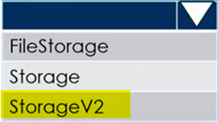

-- sku 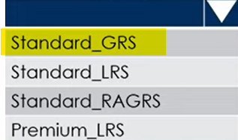

**80.** You plan to use the Azure Import/Export service to copy files to a storage account. Which two files should you create before you prepare the drives for the import job?

A. a dataset CSV file

B. an XML manifest file

C. a JSON configuration file

D. a driveset CSV file

E. a PowerShell PS1 file

**81.** You create an Azure Storage account. You plan to add 15 blob containers to the storage account. For one of the containers, you need to use a different key to encrypt data at rest. What should you do before you create the container?

A. Modify the minimum TLS version

B. Rotate the access keys

C. Create an encryption scope

D. Generate a shared access signature (SAS)

**82.** You have an Azure subscription. You plan to deploy a new storage account. You need to configure encryption for the account and the solution must meet the following requirements:

* Use the maximum supported bit length.
* Use a customer-managed key stored in a key vault.

Which type of key and which bit length should you use?

|  |  |
| --- | --- |
| **Key** | **Bit Length** |
|  |  |

**83.** You have an Azure Load Balancer named LB1. You assign a user named User1 the roles shown in the following exhibit.

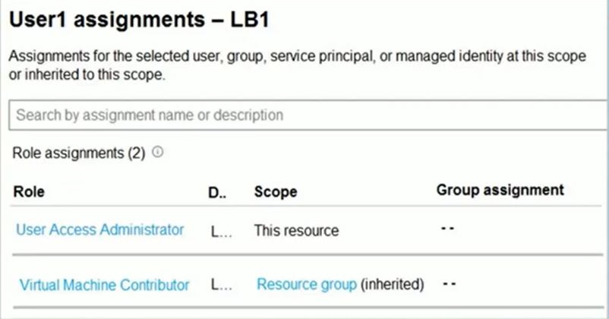

Select the answer choice that completes each statement based on the informat

presented in the graphic shown on previous slide

User1 can 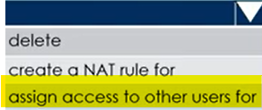 LB1

User1 can 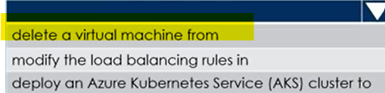 the resource group

**84.** You recently created a new Azure subscription that contains a user named Admin1. Admin1 attempts to deploy an Azure Marketplace resource by using an Azure Resource Manager template. Admin1 deploys the template by using Azure PowerShell and receives the following error message: 'User failed validation to purchase resources. Error message: 'Legal terms have not been accepted for this item on this subscription. To accept legal terms, please go to the Azure portal (http://go.microsoft.com/fwlink/?Linkld=534873) and configure programmatic deployment for the Marketplace item or create it there for the first time.' You need to ensure that Admin1 can deploy the Marketplace resource successfully.

What should you do?

A. From Azure PowerShell, run the Set-AzApiManagementSubscription cmdlet

B. From Azure PowerShell, run the Set-AzMarketplaceTerms cmdlet

C. From the Azure portal, register the Microsoft.Marketplace resource provider

D. From the Azure portal, assign the Billing /administrator role to Admin1

**85.** You have an Azure subscription that contains the resources shown in the following

table:

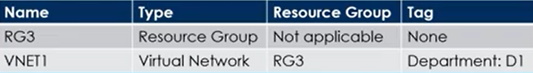

You assign a policy to RG3 as shown in the following table:

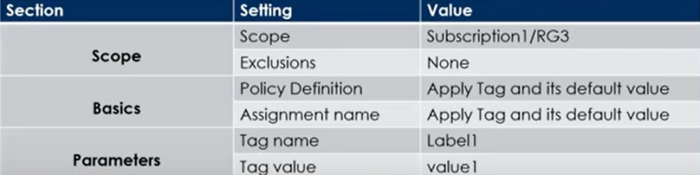

To RG3. vou apply the tag: RGroup: RG3.

You deploy a virtual petwork named VNET2 to RG3

Which tags apply to VNET1 and VNET2? To answer, select the appropriate option below .

VNET1 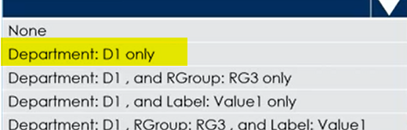

VNET2 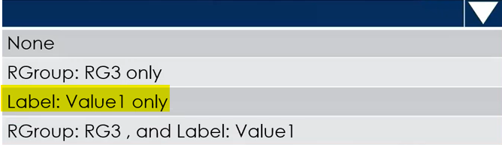

**86.** You have an Azure subscription that contains the resources shown in the following

table.

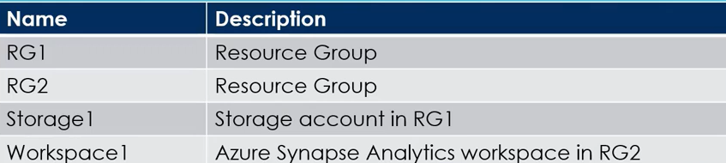

You need to assign Workspace1 a role to allow read, write, and delete operations for the data stored in the containers of storage1. Which role should you assign?

A. Reader and Data Access

B. Storage Account Contributor

C. Contributor

D. Storage Blob Data Contributor

**87.** You have an Azure AD tenant that contains the groups shown in the following table.

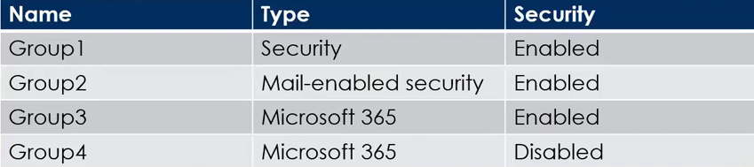

You purchase Azure Active Directory Premium P2 licenses. To which groups can you assign a license?

A. Group1 only

B. Group1 and Group3 only

C. Group3 and Group4 only

D. Group1, Group2, and Group3 only

E. Group1, Group2, Group3, and Group4

**88.** You have an Azure subscription that contains a storage account named storage1. You have the devices shown in the following table.

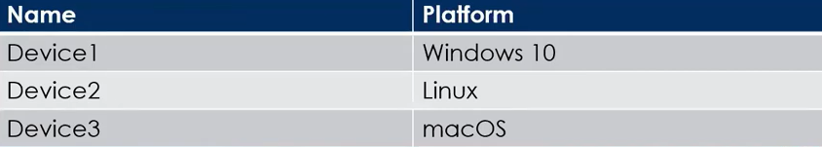

From which devices can you use AzCopy to copy data to storage1?

A. Device 1 only

B. Device1 and Device2 only

C. Device1 and Device3 only

D. Device1, Device2 and Device3

**89.** You have an Azure subscription. The subscription contains a storage account named storage1 that has the lifecycle management rules shown in the following table.

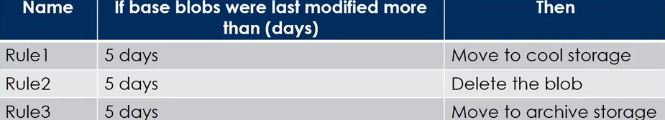

On July 1, you store a blob named File1 in the Hot access tier of storage1. What is the state of File1 on July 7?

A. Stored in the Hot access tier

B. Stored in the Cool access tier

C. Stored in the Archive access tier

D. Deleted

**89.** You plan to deploy an Azure container instance by using the following Azure

Resource Manager template.

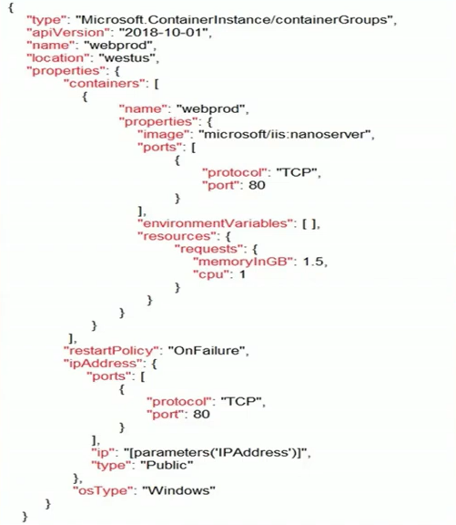

Use the drop-down menus to select the answer choice that completes each statement based on the information presented in the template.

Internet users 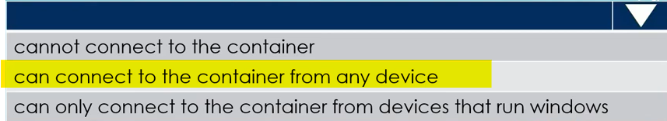

If Internet Information Services on container fails 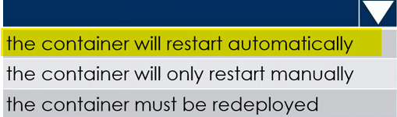

**90.** You have an Azure Subscription. You plan to deploy the Azure container instances shown in the following table.

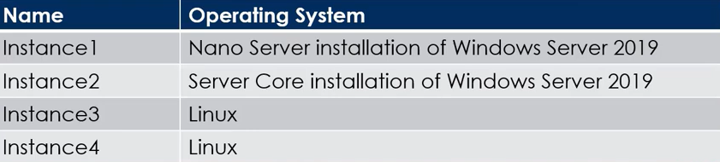

Which instances can you deploy to a container group?

A. Instance1 only

B. Instance2 only

C. Instance1 and Instance2 only

D. Instance3 and Instance4 only

**91.** You have two Azure virtual networks named VNet1 and VNet2. VNet1 contains an Azure virtual machine named VM1. VNet2 contains an Azure virtual machine named VM2. VM1 hosts a frontend application that connects to VM2 to retrieve data. Users report that the frontend application is slower than usual. You need to view the average round-trip time (RTT) of the packets from VM1 to VM2. Which Azure Network Watcher feature should you use?

A. Connection troubleshoot

B. Connection monitor

C. NSG flow logs

D. IP flow verify

**92.** How can you efficiently transfer hundreds of terabytes of media files from your organization's online library to Azure, given the limited bandwidth of your datacenter? Your solution should be fast, cost-effective, and dependable, and it must ensure 256-bit encryption. What choice will you make?

A. Data Box Edge

B. Upload using Azure portal

C. Import/Export

D. Data Box Heavy

**93.** You have an Azure subscription. You create the Azure Storage account shown in the following exhibit.

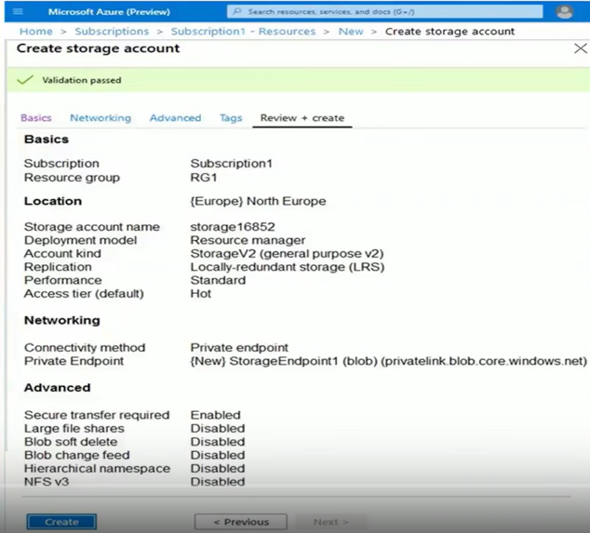

Select the answer choice that completes each statement based on the information provided in screenshot in previous tab.

The minimum number of copies of the storage account will be 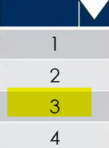

To reduce the cost of infrequently accessed data in the storage account, you must modify the 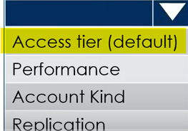 setting.

**94.** You have an Azure web app named App1. App1 has the deployment slots shown ir

the following table:

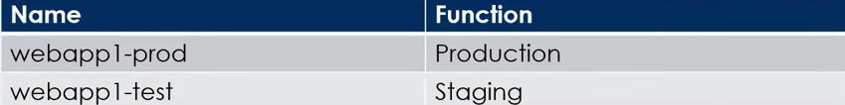

you test several changes to App1 in webapp1-test. You back up App1. You swap webapp1-test for webapp1-prod and discover that App1 is experiencing performance issues. You need to revert to the previous version of App1 as quickly as possible. What should you do?

A. Clone App1

B. Redeploy App1

C. Swap the slots

D. Restore the backup of App1

**95.** Your company wants to move all services to Azure Kubernetes service as part of application modernization. Which two of the following components contributes to the monthly Azure charge?

A. Networking resources

B. Per deployed pod

C. Master node

D. Per node VM

**96.** Your Azure subscription contains an Azure Storage account. You need to create an Azure container instance named container1 that will use a Docker image named Image1. Image1 contains a Microsoft SQL Server instance that requires persistent storage. You need to configure a storage service for Container1. What should you use?

A. Azure Blob storage

B. Azure Files

C. Azure Queue storage

D. Azure Table storage

**97.** You have Azure Active Directory tenant named Contoso.com that includes

following users:

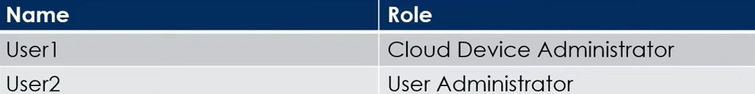

Contoso.com includes following Windows 10 devices:

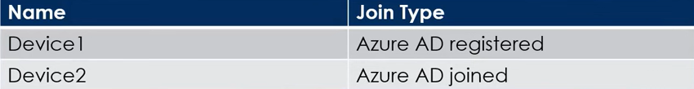

You create following security groups in Contoso.com:

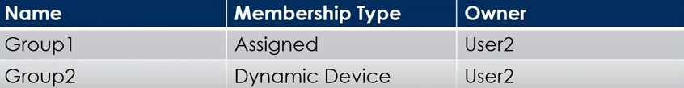

For each of the following statements, select Yes if the statement is true. Otherwise,

select No.

|  |  |
| --- | --- |
| **Statement** | **Yes/No** |
| User1 can add Device2 to Group1 | No |
| User2 can add Device1 to Group1 | Yes |
| User2 can add Device2 to Group2 | No |

**98.** You create the following resources in a subscription:

* An Azure Container Registry instance named Registry1.
* An Azure Kubernetes Service (AKS) cluster named Cluster1.

You create a container image named App1 on your administrative workstation. You need to deploy App1 to cluster1. What should you do first?

A. Run the kubect1 apply command.

B. Run the az aks create command.

C. Run the docker push command.

D. Create a host pool on Cluster1.

**99.** You have an Azure Storage account named storage1 that contains a blob container. The blob container has a default access tier of Hot. Storage1 contains a container named container1. You create lifecycle management rules in storage1 as shown in the following table.

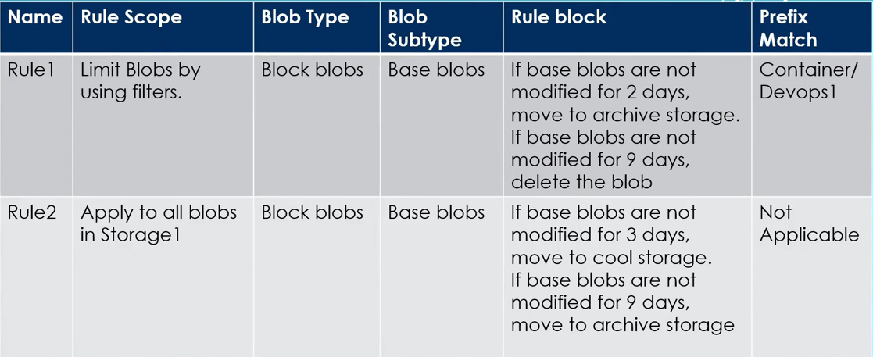

You perform the actions shown in the below table.

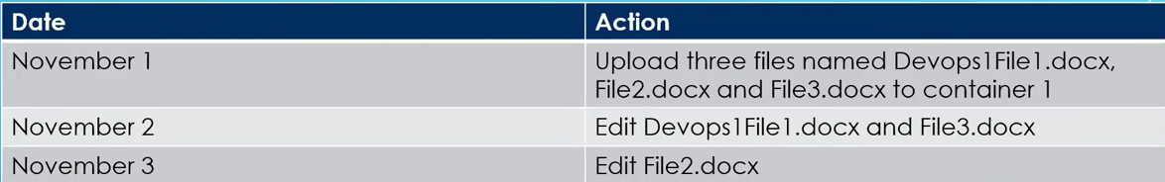

For each of the following statements, select Yes if the statement is true. Otherwise select No.

|  |  |
| --- | --- |
| **Statement** | **Yes/No** |
| On November 10, You can read Devops1File1.docx | No |
| On November 10, You can read File2.docx | Yes |
| On November 10, You can read File3.docx | Yes |

**100.** Which two of the following are an elements of Template schema?

A. Parameters

B. Includes

C. Outputs

D. Scripts

**101.** You have an Azure virtual machine (VM) that has a single data disk. You have been tasked with attaching this data disk to another Azure VM. You need to make sure that your strategy allows for the virtual machines to be offline for the least amount of time possible. Which of the following is the action you should take first?

A. Stop the VM that the data disk must be attached to.

B. Detach the data disk.

C. Delete the VM that includes the data disk.

D. Stop the VM that includes the data disk.

**102.** You have an Azure subscription that contains a storage account named storage1. The storage1 account contains a file share named share1. The subscription is linked to a hybrid Azure Active Directory (Azure AD) tenant that contains a security group named Group1. You need to grant Group1 the Storage File Data SMB Share Elevated Contributor role for share1. What should you do first?

A. Grant share-level permissions by using File Explorer

B. Mount share1 by using File Explorer

C. Create a private endpoint.

D. Enable Azure Active Directory Domain Service (AD DS) authentication for storage1.

**103.** Your on-premises network contains a VPN gateway. You have an Azure subscription that contains the resources shown in the following table:

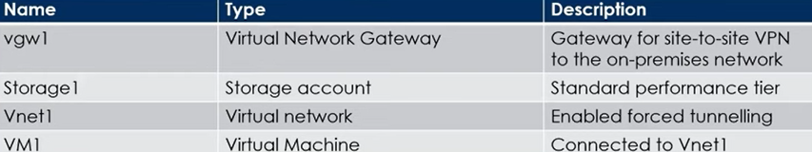

You need to ensure that all the traffic from VM1 to storage1 travels across the Microsoft backbone network. What should you configure?

A. Azure Virtual WAN

B. Private endpoints

C. Azure Application Gatewav

D. A network security group (NSG)

**104.** You have an Azure AD tenant. You need to create a Microsoft 365 group that contains only members of Marketing department in Egypt. How should you complete the dynamic membership rule? To answer, select the appropriate options in the below command

( 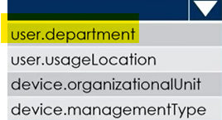 -eq “Marketing”) 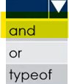(user.country 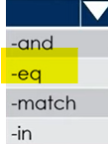 “Egypt”)

**105.** You have an Azure subscription that contains a storage account named storage1. The storage1 account contains a container named container1. You create a blob lifecycle rule named rule1. You need to configure rule1 to automatically move blobs that were NOT updated for 45 days from container to the Cool access tier. How should you complete the rule? To answer, select the appropriate options

"tierToCool": {

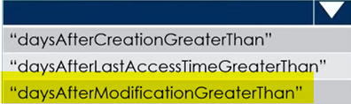:45

}

“filters”: {

“blobTypes”:[

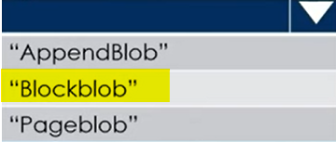

]

**106.** You have an Azure subscription that contains a virtual machine named VM1. You plan to add a 1-TB data disk to VM1 that meets the following requirements:

* + Provides data resiliency in the event of a datacenter outage.
  + Ensures that no data loss occurs if a host fails.
  + Provides the lowest latency and the highest performance.

You need to recommend which type of storage and host caching to configure for the new data disk. What will be your recommendation?

**Storage Type :**

A. Premium SSD that uses locally-redundant Storage (LRS)

B. Premium SSD that uses zone-redundant Storage (ZRS)

C. Standard SSD that uses locally-redundant Storage (LRS)

D. Standard SSD that uses zone-redundant Storage (ZRS)

**Host Caching :**

A. None

B. Read-only

C. Read/Write

**107.** You have an Azure virtual machine named VM1. VM1 was deployed by using a custom Azure Resource Manager template named ARM1.json. You receive a notification that VM1 will be affected by maintenance. You need to move VM1 to a different host immediately.

**Solution:** From the Update management blade, you click Enable.

Does this meet the goal?

A. Yes

B. No

**108.** You have an Azure Storage account named storage1 that contains a blob container named container1. You need to prevent new content added to container1 from being modified for one year. What should you configure?

A. the access level

B. the access tier

C. an access policy

D. the Access control (IAM) settings

**109.** You have an Azure subscription. You are deploying an Azure Kubernetes Service (AKS) cluster that will contain multiple pods. The pods will use Kubernetes networking. You need to restrict network traffic between the pods. What should you configure on the AKS cluster?

A. Azure network policy

B. Calico network policy

C. pod security policies

D. application security group

**110.** You host a service with two Azure virtual machines. You discover that occasional outages cause your service to fail. What two actions can you do to minimize the impact of the outages?

A. Put the virtual machines in a scale set.

B. Add a network gateway.

C. Add a load balancer.

D. Add a third instance of the virtual machine.

E. Put the virtual machines in an availability set.

**111.** You have an Azure subscription named Subscription1. In Subscription1, you create an alert rule named Alert1. The Alert1 action group is configured as shown in the following exhibit.

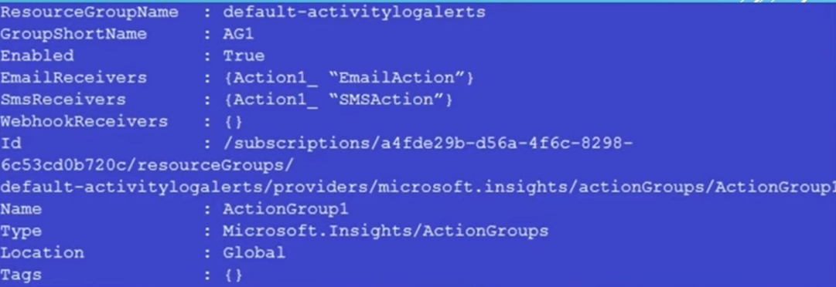

Alert1 alert criteria is to be triggered every minute. Select the answer choice that completes each statement based on the information presented in the graphic.

The number of email messages that Alert1 will send in an hour is 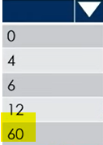

The number of sms messages that Alert1 will send in an hour is 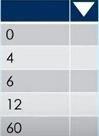

**112.** You have Azure subscription that includes following Azure file shares:

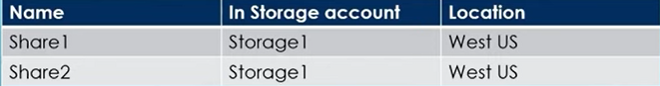

You have the following on-premises servers:

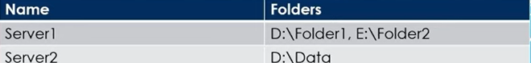

You create a Storage Sync Service named Sync1 and an Azure File Sync group named Group1. Group1 uses Share1 as a cloud endpoint. You register Server1 and Server2 in Sync1. You add D:Folder1 on Server1 as'a server endpoint of Group1. For each of the following statements, select Yes if the statement is true. Other select No.

**Statement1:** Share2 can be added as a cloud endpoint for Group1 Yes/No

**Statement2:** D:Data on Server2 can be added as a server endpoint for Group1 Yes/ No

**Statement3:** E:\Folder2 on Server1 can be added as a server endpoint for Group1 Yes/No

**113.** You have an Azure subscription that contains 10 virtual networks. The virtual networks are hosted in separate resource groups. Another administrator plans to create several network security groups (NSGs) in the subscription. You need to ensure that when an NSG is created, it automatically blocks TCP port 8080 between the virtual networks.

**Solution:** From the Resource providers blade, you unregister the Microsoft.ClassicNetwork provider.

Does this meet the goal?

A. Yes

B. No

**114.** You have a production Azure Active Directory (Azure AD) tenant named contoso.com. You deploy a development Azure Active Directory (AD) tenant, and then you create several custom administrative roles in the development tenant. You need to copy the roles to the production tenant. What should you do first?

A. From the production tenant, create a new custom role.

B. From the production tenant, create an administrative unit.

C. From the development tenant, export the custom roles to JSON.

D. From the development tenant, perform a backup.

**115.** You plan to use Azure Network Watcher to perform the following tasks:

* Task1: Identify a security rule that prevents a network packet from reaching an Azure virtual machine.
* Task2: Validate outbound connectivity from an Azure virtual machine to an external host.

Which feature should you use for each task? To answer, select the appropriate options below :

**Task 1:** 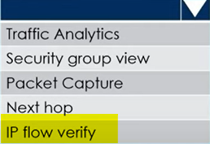

**Task 2:** 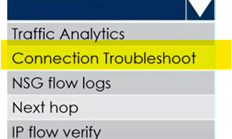

**116.** You have deployed an application named App1 in Azure. App1 is deployed on two Azure virtual machines named VM1 and VM2. You plan to implement an Azure Availability Set for App1. The solution must ensure that App1 is available during planned maintenance of the servers hosting VM1 and VM2. What should you include in the Availability Set?

A. Single update domain

B. Single fault domain

C. Two update domains

D. Two fault domains

**117.** You have deployed an application named App1 in Azure. App1 is deployed on two Azure virtual machines named VM1 and VM2. You plan to implement an Azure Availability Set for App1. The solution must ensure that App1 is available during unplanned maintenance of the servers hosting VM1 and VM2. What should you include in the Availability Set?

A. Single update domain

B. Single fault domain

C. Two update domains

D. Two fault domains

**118.** You manage a virtual network named VNet1 that is hosted in the East US Azure region. VNet1 hosts two virtual machines named VM1 and VM2 that run Windows Server. You need to inspect all the network traffic from VM1 to VM2 for a period of three hours.

**Solution:** From Azure Network Watcher, you create a packet capture.

Does this meet the goal?

A. Yes

B. No

**119.** You have an Azure subscription that contains the public load balancers shown in the following table.

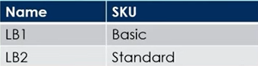

You plan to create six virtual machines and to load balance requests to the virtual machines. Each load balancer will load balance three virtual machines. You need to create the virtual machines for the planned solution. How should you create the virtual machines? To answer, select the appropriate options below :-

**The Virtual Machines that will be load balanced by using LB1 must:**

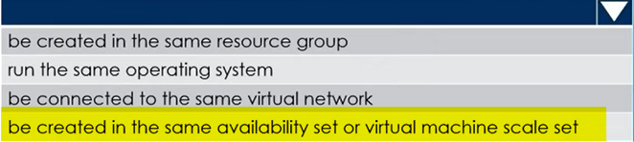

**The Virtual Machines that will be load balanced by using LB2 must:**

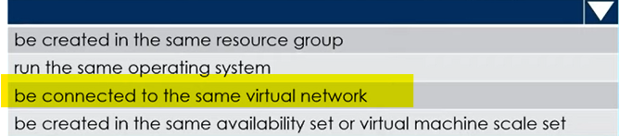

**120.** You have a script that creates several VM's with different images. When the script issues the command to create the first VM you do not want to block the script while the VM is created, instead you want the script to immediately move on to the next command. What is the best way to do this?

A. Use the ampersand (&) to run the process in the background.

B. Add the ' -- no-wait' argument to your create command.

C. Add the ' -- async' argument to your create command.

**121.** You have an Azure subscription. You plan to deploy an Azure Kubernetes Service (AKS) cluster to support an app named App1. On-premises clients connect to App1 by using the IP address of the pod. For the AKS cluster, you need to choose a network type that will support App1. What should you choose?

A. Hybrid Connection endpoints

B. Azure Private Link

C. Kubenet

D. Azure Container Networking Interface (CNI)

**122.** You have an Azure subscription named Subscription1. Subscription1 contains th

resources in the following table.

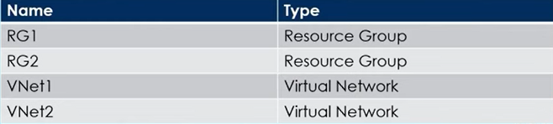

VNet1 is in RG1, VNet2 is in RG2 and there is no connectivity between VNet1 and VNet2. An administrator named Admin1 creates an Azure virtual machine named VM1 in RG1. VM1 uses a disk named Disk1 and connects to VNet1. Admin1 then installs a custom application in VM1. You need to move the custom application to VNet2 and the solution must minimize administrative effort. Which two actions should you perform? To answer, select the appropriate answer among the options provided.

**First Action:** 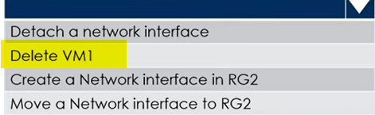

**Second Action:** 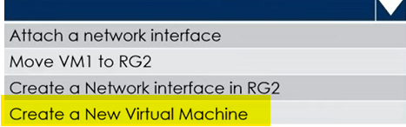

**123**. You have an Azure subscription that contains an Azure Storage account named storageaccount1. You export storageaccount1 as an Azure Resource Manager template.

The template contains the following sections.

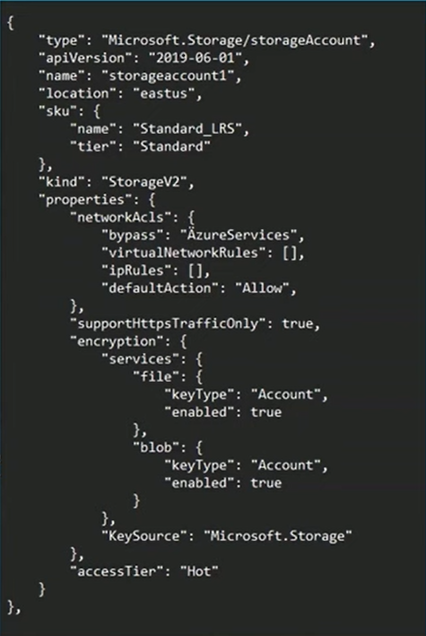

For each of the following statements, select Yes if the statement is true. Otherwise, select No

**Statement1:** A Server that has a Public IP address of 131.107.103.10 can access storageaccount1.

Yes/No

**Statement2:** Individual blobs in storageaccount1 can beset to use the archive tier.

Yes/No

**Statement3:** Global Administrators in Azure Active Directorycan access a file share hosted in storageaccount1by using their Azure AD credentials.

Yes/No

**124.** You onboard 10 Azure virtual machines to Azure Automation State Configuration and you need to use Azure Automation State Configuration to manage the ongoing consistency of the virtual machine configurations. Which three actions should you perform in sequence?

1. Create a Management Group

2. Check the compliance status of the node **3**

3. Assign tags to the Virtual machines.

4. Compile configuration into node configuration **2**

5. Import configuration to Azure automation State configuration **1**

**125.** You have a Azure virtual network named VNet1 that contains a subnet named Subnet1. Subnet1 contains 3 Azure virtual machines and each virtual machine has a public IP address. The virtual machines host several applications that are accessible over port 443 to users on the Internet. Your on-premises network has a site-to-site VPN connection to VNet1 and you discover that the VM's can be accessed over RDP from Internet and from on-premises network. You need to prevent RDP access to the virtual machines from the Internet, unless the RDP connection is established from the on-premises network. The solution must ensure that all the applications can still be accessed by the Internet users.

How can you achieve this requirement?

A. Create a deny rule in a network security group (NSG) that is linked to Subnet1

B. Modify the address space of Subnet1.

C. Modify the address space of the local network gateway.

D. Remove the public IP addresses from the virtual machines.

**126.** You have an Azure subscription that contains two on-premises locations named site1 and site2. You need to connect site1 and site2 by using an Azure Virtual WAN. Which of the following four actions should you perform in sequence?

1. Create a Virtual WAN Resource. **1**

2. Create VPN Sites.  **3**

3. Connect the VPN sites to the hub. **4**

4. Create a Virtual Hub. **2**

5. Connect the Virtual networks to the hub

**127.** You have an Azure subscription. Users access the resources in the subscription from either home or from customer sites. From home, users must establish a point-to-site VPN to access the Azure resources. The users on the customer sites access the Azure resources by using site-to-site VPNs. You have a line-of-business- app named App1 that runs on several Azure virtual machine. The virtual machines run Windows Server 2019. You need to ensure that the connections to App1 are spread across all the virtual machines. What are two possible Azure

services that you can use?

A. Traffic Manager

B. Public load balancer

C. Azure Content Delivery Network

D. Azure Application Gateway

E. Internal load balancer

**128.** You have a pay-as-you-go Azure subscription that contains the virtual machines

shown in the following table.

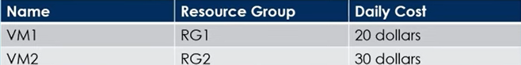

You create the budget shown in the exhibit below.

|  |  |
| --- | --- |
| The AG1 action group contains a user named [admin@contoso.com](mailto:admin@contoso.com) only. Select the answer choice that completes each statement based on the information presented in the graphic. |  |

When the maximum amount in Budget1 is reached 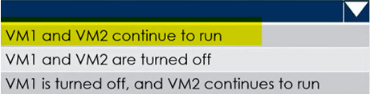

Based on the current usage costs of the virtual machines 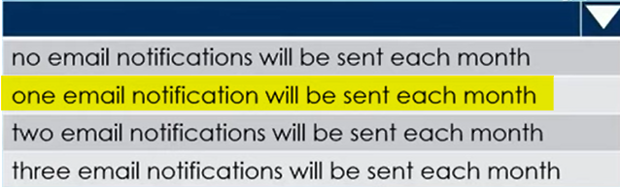

**129.** You have an Azure subscription that contains the resources as shown below

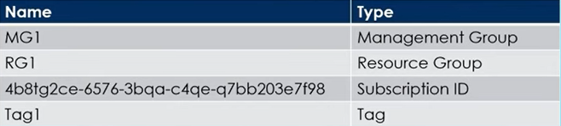

In Azure Cloud Shell, you need to create a virtual machine by using an Azure Resource Manager (ARM) template. How should you complete the command?

$adminPassword =Read-Host -Prompt "Enter the Admin Password" -AsSecureString

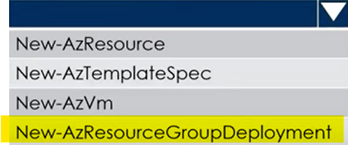 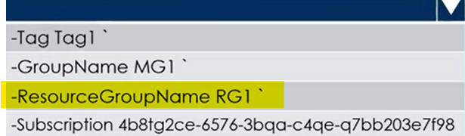

-TemplateUri https://raw.githubusercontent.com/azure-templates/azuredeploy.json

-adminUsername LocalAdmin -adminPassword $adminPassword -dnsLabelPrefix TestVM1

**130.** You have a Azure virtual network named VNet1 that contains a subnet named Subnet1. Subnet1 contains 3 Azure virtual machines and each virtual machine has a public IP address. The virtual machines host several applications that are accessible over port 443 to users on the Internet. Your on-premises network has a site-to-site VPN connection to VNet1 and you discover that the VM's can be accessed over RDP from Internet and from on-premises network. You need to prevent RDP access to the virtual machines from the Internet, unless the RDP connection is established from the on-premises network. The solution must ensure that all the applications can still be accessed by the Internet users.

How can you achieve this requirement?

A. Create a deny rule in a network security group (NSG) that is linked to Subnet1.

B. Modify the address space of Subnet1.

C. Modify the address space of the local network gateway.

D. Remove the public IP addresses from the virtual machines.

**131.** You configure the custom role shown in the following exhibit.

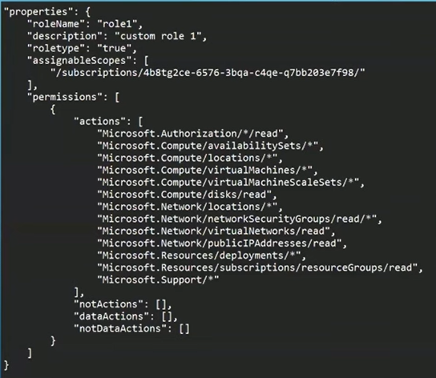

Use the drop-down menus to select the answer choice that completes each statement based on the information presented in the graphic.

To ensure that users can sign in to virtual machines that are assigned role1, modify the 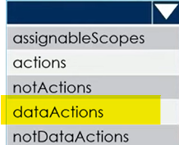 section.

To ensure that role1 can be assigned only to a resource group named RG1, modify the

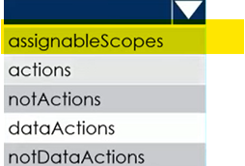section.

**132.** You have an Azure subscription that contains a virtual machine named VM1 and an Azure key vault named KV1. You need to configure encryption for VM1. The solution must meet the following requirements:

* + Maintain encryption if VM1 is downloaded from Azure.
  + Encrypt both the operating system disk and the data disks.
  + Store and use the encryption key in KV1.

Which encryption method should you use?

A. Azure Disk Encryption

B. Customer-managed keys

C. Confidential disk encryption

D. Encryption at host

**133.** You have 10 Azure subscriptions. You have an Azure Active Directory (Azure AD) tenant that contains a security group named Group1 and you plan to purchase additional Azure subscription. You need to ensure that Group1 can manage role assignments for the existing subscriptions and the planned subscriptions. The solution must meet the following requirements:

* Use the principle of least privilege.
* Minimize administrative effort.

What should you do?

A. Create a new management group and assign Group1 the User Access Administrator

role for the group.

B. Create a new management group and assign Group1 the Owner role for the group.

C. Assign Group1 the Owner role for the root management group.

D. Assign Group1 the User Access Administrator role for the root management group.

**134.** You have an Azure subscription that contains a storage account named storage1. Subscription is linked to an Azure AD tenant named contoso.com that syncs to an on-premises Active Directory domain. The domain contains the security principals shown in the following table.

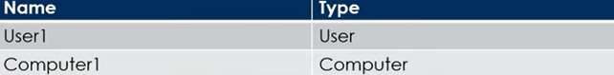

In Azure AD, you create a user named User2. Storage1 account contains a file share named share1 and has the following configurations.

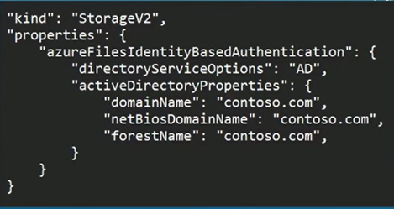

For each of the following statements, select Yes if the statement is true. Otherwise, select No.

**Statement1:**

You can assign the Storage File data SMB Share reader role to Computer1 for Share1 Yes/No

**Statement2:**

You can assign the Storage File data SMB Share Contributor role to User1 for Share1 Yes/No

**Statement3:**

You can assign the storage File Data SMB Share Elevated Contributor role to user2 for share1. Yes/No

**135.** You have an Azure App Services web app named App1. You plan to deploy App1 by using Web Deploy. You need to ensure that the developers of App1 can use their Azure AD credentials to deploy content to App1. The solution must use the principle of least privilege. What should you do?

A. Configure user-level credentials for FTPS.

B. Configure app-level credentials for FTPS.

C. Assign the Owner role to the developers.

D. Assign the Website Contributor role to the developers.

**136.** You have an Azure subscription that contains two virtual machines as shown in the following table.

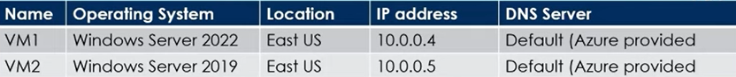

You perform a reverse DNS lookup for 10.0.0.4 from VM2. Which FQDN will be returned?

A. vm1.eastus.cloudapp.azure.com

B. vm1.core.windows.net

C. vm1.internal.cloudapp.net

D. vm1.azure.com

<https://learn.microsoft.com/en-us/azure/virtual-network/virtual-networks-name-resolution-for-vms-and-role-instances?tabs=redhat#reverse-dns-considerations>

**137.** You plan to deploy route-based Site-to-Site VPN connections between several on-premises locations and an Azure virtual network. Which tunneling protocol should you use?

A. PPTP

B. IKEv1

C. IKEv2

D. L2TP

**138.** You have an Azure virtual machine named VM1 that runs Windows Server 2016. You need to create an alert in Azure when more than two error events are logged to the System event log on VM1 within an hour.

**Solution:** You create an Azure Log Analytics workspace and configure the data settings. You install the Microsoft Monitoring Agent on VM1. You create an alert in Azure Monitor and specify the Log Analytics workspace as the source.

Does this meet the goal?

A.Yes

B. No

|  |  |
| --- | --- |
| **139.** You have an Azure subscription that contains the hierarchy shown in the following exhibit. You create an Azure Policy definition named Policy1. To which Azure resources can you assign Policy1 and which Azure resources can you specify as exclusions from Policy1?  You can apply Policy1 to:    Which ones can be excluded from Policy1: |  |

**140.** You have an Azure subscription that contains a storage account named storage1. You plan to use conditions when assigning role-based access control (RBAC) roles to storage1. Which of the following storage1 services support conditions when assigning roles?

A. queues only

B. file shares only

C. containers only

D. tables only

E. files shares and tables only

F. containers and queues only

**141.** You have an Azure subscription named Subscription1 that contains the quotas shown in the following table.

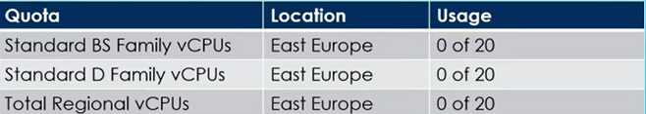

You deploy virtual machines to Subscription1 as shown in the following table.

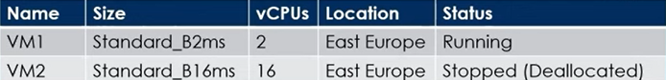

You plan to deploy the virtual machines shown in the following table.

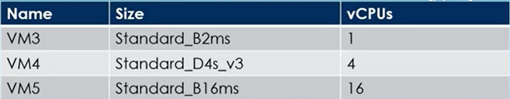

For each of the following statements, select Yes if the statement is true.

Otherwise, select No.

**Statement1:**

You can deploy VM3 to East Europe Yes/No

**Statement2:**

You can deploy VM4 to East Europe Yes/No

**Statement3:**

You can deploy VM5 to East Europe Yes/No

**142.** You have an Azure subscription that contains the resources shown in the following table.

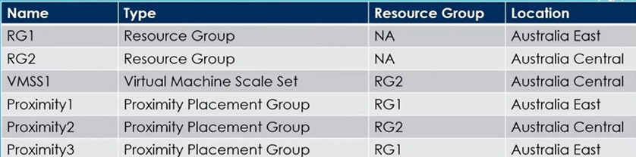

You need to configure a proximity placement group for VMSS1. Which proximity placement groups should you use?

A. Proximity1 only

B. Proximity2 only

C. Proximity1 and Proximity3 only

D. Proximity1, Proximity2 and Proximíty3

**143.** You have an Azure subscription that contains an Azure file share. You have an on-premises server named Server1 that runs Windows Server 2016. You plan to set up Azure File Sync between Server1 and the Azure file share. You need to prepare the subscription for the planned Azure File Sync. Which two actions should you perform in the Azure subscription?

A. Run Server registration

B. Create a Storage Sync Service

C. Install the Azure File Sync agent

D. Create a sync group.

**144.** You have an Microsoft Entra ID tenant named contoso.com that contains the users shown in the following table.

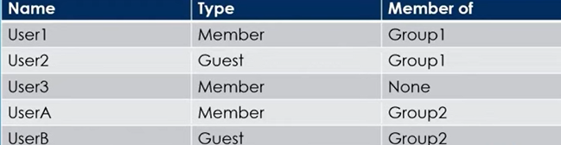

User3 is the owner of Group1. Group2 is a member of Group1. You configure an access review named Review1 shown in the exhibit on next screen.

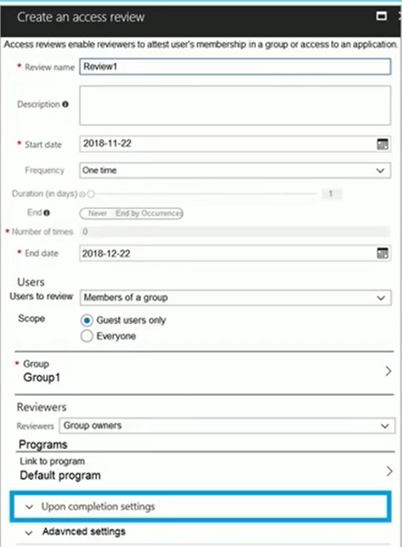

For each of the following statements, select Yes if the statement is true. Otherwise, select No.

**Statement1:**

User3 can perform an access review of UserA. Yes/No

**Statement2:**

User3 can perform an access review of UserB. Yes/No

**Statement3:**

User3 can perform an access review of User1. Yes/No

**145.** You have an Azure subscription named Subscription1 that contains an Azure virtual machine named VM1. VM1 is in a resource group named RG1. VM1 runs services that will be used to deploy resources to RG1. You need to ensure that a service running on VM1 can manage the resources in RG1 by using the identity of VM1. What should you do first?

A. From the Azure portal, modify the Access control (IAM) settings of RG1.

B. From the Azure portal, modify the Policies settings of RG1.

C. From the Azure portal, modify the Managed Identity settings of VM1.

D. From the Azure portal, modify the Access control (IAM) settings of VM1.

**146.** You need to ensure that an Azure Active Directory (Azure AD) user named Admin1 is assigned the required role to enable Traffic Analytics for an Azure subscription.

**Solution:** You assign the Traffic Manager Contributor role at the subscription level to Admin1.

Does this meet the goal?

A. Yes

B. No

**147.** You have two Azure virtual machines named VM1 and VM2 and you have two Recovery Services vaults named RSV1 and RSV2. VM2 is backed up to RSV1 and you need to back up VM2 to RSV2. What should you do first?

A. From the RSV1 blade, click Backup Jobs and export the VM2 job.

B. From the RSV2 blade, click Backup. From the Backup blade, select the backup.

for the virtual machine, and then click Backup.

C. From the RSV1 blade, click Backup items and stop the VM2 backup.

D. From the VM2 blade, click Disaster recovery, click Replication settings, and

then select RSV2 as the Recovery Services vault.

**148.** You have an Azure subscription that contains the resources shown in the following table.

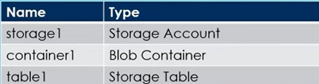

You need to perform the tasks shows in below table

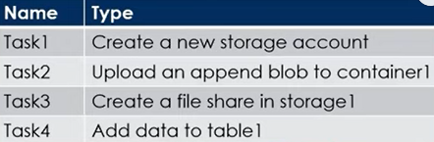

Which tasks can you perform by using Azure Storage Explorer?

A. Task1 and Task3 only

B. Task1, Task2, and Task3 only

C. Task1, Task3, and Task4 only

D. Task2, Task3, and Task4 only

E. Task1, Task2, Task3, and Task4

**149.**  You have three Azure subscriptions named Sub1, Sub2, and Sub3 that are linked to an Entra ID tenant. The tenant contains a user named User1, a security group named Group1, and a management group named MG1. User1 is a member of Group1. Sub1 and Sub2 are members of MG1. Sub1 contains a resource group named RG1. RG1 contains five Azure functions. You create the following role assignments for MG1:

* Group1: Reader
* User1: User Access Administrator

You assign User1 the Virtual Machine Contributor role for Sub1 and Sub2. For each of the following statements, select Yes if the statement is true. Otherwise, select No.

**Statement1:**

User1 can assign the owner role for RG1. Yes/No

**Statement2:**

The Group1 members can view the configurations of the Azure Functions. Yes/No

**Statement3:**

User1 can create a new resource group and deploy a virtual machine to the new group. Yes/No

**150.** You have an Azure subscription named Subscription1 that contains two Azure virtual networks named VNet1 and VNet2. VNet1 contains a VPN gateway named VPNGW1 that uses static routing. There is a site-to-site VPN connection between your on-premises network and VNet1. On a computer named Client1 that runs Windows 10, you configure a point-to-site VPN connection to VNet1. You configure virtual network peering between VNet1 and VNet2. You verify that you can connect to VNet2 from the on-premises network. Client1 is unable to connect to VNet2. You need to ensure that you can connect Client1 to VNet2.

What should you do?

A. Select Allow gateway transit on VNet2.

B. Download and re-install the VPN client configuration package on Client1.

C. Enable BGP on VPNGW1

D. Select Allow gateway transit on VNet1.

**151.** You have five Azure virtual machines that run Windows Server 2019. The virtual machines are configured as web servers. You have an Azure load balancer named LB1 that provides load balancing services for the virtual machines. You need to ensure that visitors are serviced by the same web server for each request. What should you configure?

A. Protocol to UDP

B. Session persistence to Client IP and protocol

C. Floating IP to Enabled

D. Session persistence to None

**152.** You have an Azure subscription named Sub1 that contains the resources shown

the following table.

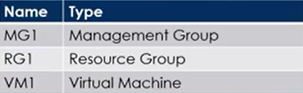

You create a user named Admin1. To what can you add Admin1 as a co-administrator?

A. RG1

B. MG1

C. Sub1

D. VM1

**153.** You have a Microsoft Entra tenant that contains the groups shown in the following table.

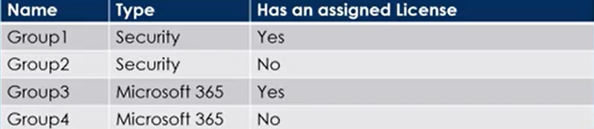

The Tenant contains the users shown in the following table.

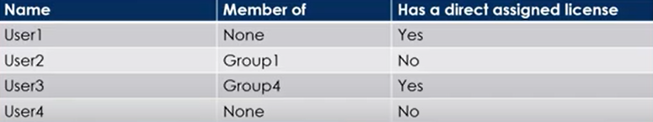

Which users and groups can you delete?

**Users:** 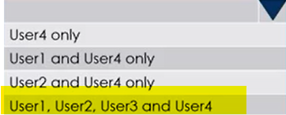

**Groups:** 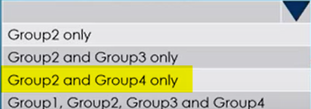

**154.** You have an Microsoft Entra tenant. You plan to delete multiple users by using Bulk delete in the Entra admin center. You need to create and upload a file for the bulk delete. Which user attributes should you include in the file?

A. The user principal name and usage location of each user only

B. The user principal name of each user only

C. The display name of each user only

D. The display name and usage location of each user only

E. The display name and user principal name of each user only

**155.** You have an Azure subscription that contains a resource group named TestRG. You use TestRG to validate an Azure Deployment. TestRG contains the following resources:

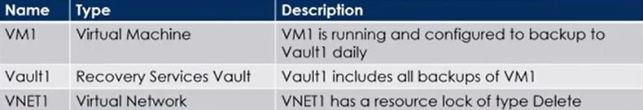

You need to delete TestRG. What should you do first?

A. Modify the backup configurations of VM1 and modify the resource lock type of VNET1

B. Remove the resource lock from VNET1 and delete all data in Vault1

C. Turn off VM1 and remove the resource lock from VNET1

D. Turn off VM1 and delete all data in Vault1

**156.** You have an Azure subscription that contains the resources shown in the following table.

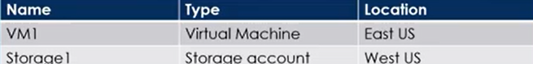

You need to ensure that data transfers between storage1 and VM1 do NOT traverse the internet. What should you configure for storage1?

A. Data Protection

B. A Private endpoint

C. Public network access in the Firewalls and virtual networks settings

D. A shared access signature (SAS)

**157.** You have an Azure virtual machine named VM1 and an Azure key vault named Vault1. On VM1, you plan to configure Azure Disk Encryption to use a key encryption key (KEK). You need to prepare Vault1 for Azure Disk Encryption. Which two actions should you perform on Vault1?

A. Select Azure Virtual machines for deployment.

B. Create a new key.

C. Create a new secret.

D. Configure a key rotation policy.

E. Select Azure Disk Encryption for volume encryption.

**158.** You have an Azure subscription. You plan to create a role definition to meet the following requirements:

* Users must be able to view the configuration data of a storage account.
* Users must be able to perform all actions on a virtual network.
* The solution must use the principle of least privilege.

What should you include in the role definition for each of the below mentioned

requirements?

**Perform all actions on a virtual network:**

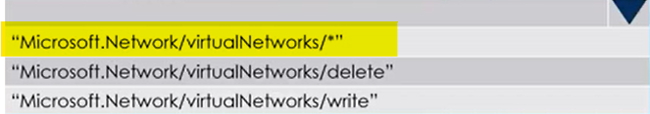

**View the configuration data of a storage account:**

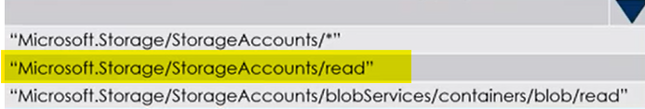

**159.** You have an Azure subscription that contains a storage account named storage1. You need to configure a shared access signature (SAS) to ensure that users can only download blobs securely by name. Which two settings should you configure? To answer, select the appropriate settings below.

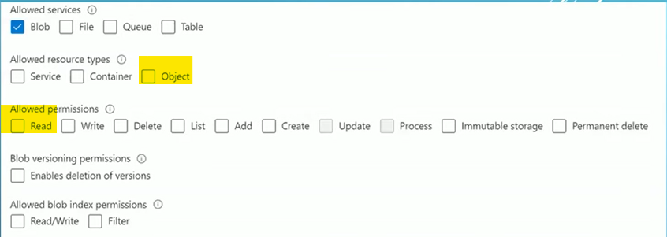

**160.** You need to create an Azure Storage account named storage1. The solution must meet the following requirements:

* Support Azure Data Lake Storage.
* Minimize costs for infrequently accessed data.
* Automatically replicate data to a secondary Azure region.

Which three options should you configure for storage1? Each correct answer presents part of the solution.

A. Zone-redundant storage (ZRS)

B. Cool access tier

C. Geo-redundant storage (GRS)

D. Hot access tier

E. Hierarchical namespace

**161.** You have an Azure subscription that contains the devices shown in the following table.

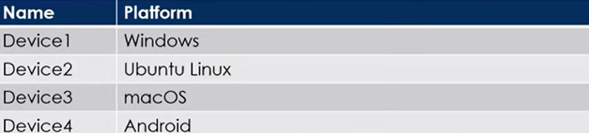

A. Device1 only

B. Device1 and Device2 only

C. Device1 and Device3 only

D. Device1, Device2 and Device3 only

E. Device1, Device3 and Device4 only

**162.** You have an Azure subscription that contains multiple virtual machines in the West US Azure region. You need to use Traffic Analytics in Azure Network Watcher to monitor virtual machine traffic. Which two resources should you create?

A. Log Analytics workspace

B. Azure Monitor workbook

C. Storage account

D. Microsoft Sentinel workspace

E. Data Collection Rule (DCR) in Azure Monitor

**163.** You have an Azure Storage account named storage1 that contains two containers named container1 and container2. Blob versioning is enabled for both containers and you periodically take blob snapshots of critical blobs. You create the following lifecycle management policy

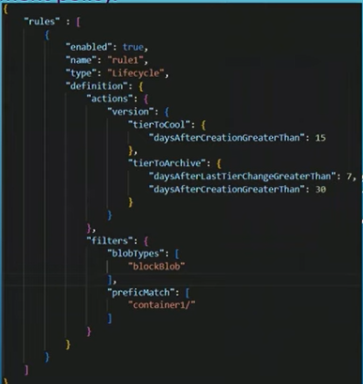.

For each of the following statements, select Yes if the statement is true. Otherwise, select No

**Statement1:**

A Blob Snapshot automatically moves to the Cool access Tier after 15 days Yes/No

**Statement2:**

A Blob version in container2 automatically moves to the Archive access Tier after 30 days Yes/No

**Statement3:**

A rehydrated version in container1 automatically moves to the Archive access tier after 30 days Yes/No

**164.** You have an Azure subscription that contains the virtual networks shown in the following table.

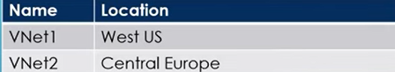

You need to ensure that all the traffic between VNet1 and VNet2 traverses the Microsoft backbone network. What should you configure?

A. Private endpoint

B. Peering

C. Express Route

D. Route table

**165.** You have an Azure subscription and you are creating a new Azure container instance that will have the following settings:

* Container name: cont1
* SKU: Standard
* OS type: Windows
* Networking type: Public
* Memory (GiB): 2.5
* Number of CPU cores: 2

You discover that the Private setting for Networking type is unavailable. You need to ensure that cont1 can be configured to use private networking. Which setting should you change?

A. Memory (GiB)

B. Networking type

C. Number of CPU cores

D. OS type.

**166.** You have an Azure subscription that contains an Azure container registry named ContReg1. You enable the Admin user for ContReg1. Which username can you use to sign in to ContReg1?

A. root

B. admin

C. administrator

D. ContReg1

**167.** You have an Microsoft Entra tenant named devopshub.com. You have an Azure subscription that contains an Azure App Service web app named App1 and an Azure key vault named KV1. KV1 contains a wildcard certificate for devopshub.com. You have a user named user1@devopshub.com that is assigned the Owner role for App1 and KV1. You need to configure App1 to use the wildcard certificate of KV1. What should you do first?

A. Assign a managed user identity to App1.

B. Create an access policy for KV1 and assign the Microsoft Azure App Service principal to the policy.

C. Create an access policy for KV1 and assign the policy to User1.

D. Configure KV1 to use the role-based access control (RBAC) authorization system.

**168.** You have an Azure subscription that contains storage accounts shown in the following table

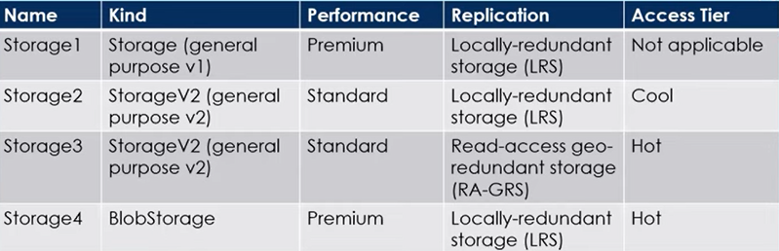

Which storage account can be converted to Zone -redundant (ZRS) replication?

A. Storage1

B. Storage2

C. Storage3

D. Storage4

**169.** You have an Azure subscription that contains the virtual machines shown in the following table

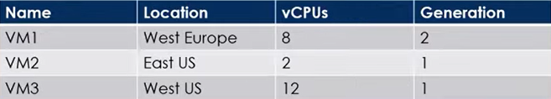

You create an Azure Compute Gallery named ComputeGallery1 as shown in the Azure Compute Gallery exhibit below :

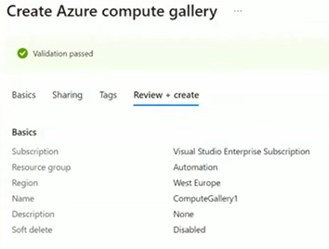

In ComputeGallery1, you create a virtual machine image definition named Image1 as shown in the image definition exhibit.

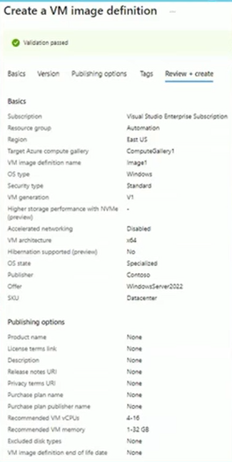

For each of the following statements, select Yes if the statement is true. Otherwise, select No,

**Statement1:**

The Operating System disk of VM1 can be used as a source for a version of Image1 Yes/No

**Statement2:**

The Operating System disk of VM2 can be used as a source for a version of Image1 Yes/No

**170.** You have an Azure subscription that contains the container images shown in the following table.

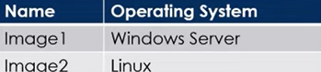

You plan to use the following services:

* Azure Container Instances
* Azure Container Apps
* Azure App Service

In which services can you run the images?

**Image1:** 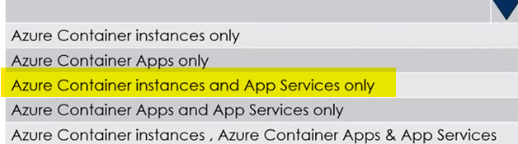

**Image2:** 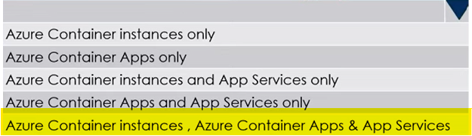

**171.** You have an Azure subscription that contains a resource group named RG1. You plan to create a storage account named storage1.You have a Bicep file named File1. You need to modify File1 so that it can be used to automate the deployment of storage1 to RG1. Which property should you modify?

A. kind

B. scope

C. sku

D. location

**172.** You have an Azure subscription. You plan to deploy the resources shown in the following table.

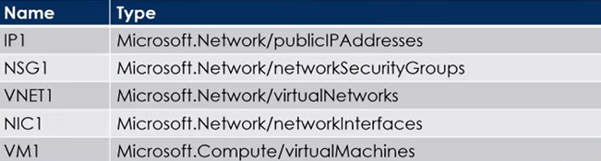

You need to create a single Azure Resource Manager (ARM) template that will be used to deploy the resources. Which resource should be added to the dependsOn section for VM1?

A. VNET1

B. NIC1

C. IP1

D. NSG1

**173.** You have an Azure subscription that contains a storage account named storage1. The storage1 account contains a container named container1. You need to configure access to container1, and the solution must meet the following requirements:

* Only allow read access.
* Allow both HTTP and HTTPS protocols.
* Apply access permissions to all the content in the container.

What should you use?

A. an access policy

B. a shared access signature (SAS)

C. Azure Content Delivery Network (CDN)

D. access keys

**174.** You have an Azure subscription that contains the virtual networks shown in the following table.

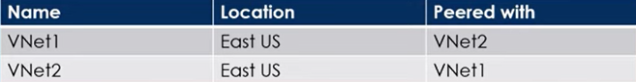

Each virtual network has 50 connected virtual machines. You need to implement Azure Bastion. The solution must meet the fallowing requirements:

* Support host scaling.
* Support uploading and downloading files.
* Support the virtual machines on both VNet1 and VNet2.
* Minimize the number of addresses on the Azure Bastion subnet.

How should you configure Azure Bastion?

**Subnet size:** 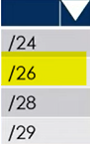

**Public IP:** 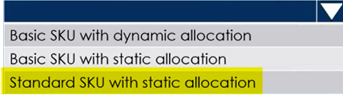

<https://learn.microsoft.com/en-us/azure/bastion/configuration-settings>

**175.** You plan to deploy several Azure virtual machines that will run Windows Server 2029 in a virtual machine scale set by using an Azure Resource Manager template. You need to ensure that NGINX is available on all the virtual machines after they are deployed. What should you use?

A. the Publish-AzVMDscConfiguration cmdlet

B. Azure Application Insights

C. Azure Custom Script Extension

D. the New-AzConfigurationAssignement cmdlet

**176.** You have an Azure subscription that contains a Recovery Services vault named Vault1. You need to enable multi-user authorization (MAU) for Vault1. Which resource should you create first?

A. an administrative unit

B. a managed identity

C. a resource guard

D. a custom Azure role

<https://learn.microsoft.com/en-us/azure/backup/multi-user-authorization-concept?tabs=recovery-services-vault>

**177.** You have an on-premises datacenter and an Azure subscription. You plan to connect the datacenter to Azure by using ExpressRoute. You need to deploy an ExpressRoute gateway. The solution must meet the following requirements?

* Support up to 10 Gbps of traffic.
* Support availability zones.
* Support FastPath.
* Minimize costs.

Which SKU should you deploy?

A. ERGw1Az

B. ERGw2

C. ErGw3

D. ErGw3Az

**178.** You have an Azure subscription. You plan to migrate 50 virtual machines from VMware vSphere to the subscription. You create a Recovery Services vault.

What should you do next?

A. Configure an extended network.

B. Create a recovery plan.

C. Deploy an Open Virtualization Application (OVA) template to vSphere.

D. Configure a virtual network.

**179.** You have an Azure subscription that contains a resource group named RG1. You plan to create an Azure Resource Manager (ARM) template to deploy a new virtual machine named VM1. VM1 must support the capture of performance data. You need to specify resource dependencies for the ARM template. In which order should you deploy the resources? To answer, move all resources from the list of resources to the answer area and arrange them in the correct order.

|  |  |
| --- | --- |
| **Resources** | **Answer area** |
| Azure Monitor Extension  Virtual Machine  Virtual Network  Network Interface | Azure Monitor Extension  Virtual Machine  Network Interface  Virtual Network |

**180.** You have an Azure subscription that contains the virtual networks shown in the following table.

|  |  |
| --- | --- |
| All the virtual networks are peered. Each virtual network contains 9 virtual machines. You need to configure secure RDP connections  to the virtual machines by using Azure Bastion.  What is the minimum number of Bastion hosts  required? |  |

A. 1

B. 3

C. 9

D. 10

**181.** You have an Azure subscription that contains 10 network security groups (NSGs 10 virtual machines, and a Log Analytics workspace named Workspace1. Each NSG is connected to a virtual machine. You need to configure an Azure Monitor Network Insights alert that will be triggered when suspicious network traffic is detected. What should you do first?

A. Deploy Connection Monitor.

B. Configure data collection endpoints.

C. Configure a private link.

D. Configure NSG flow logs.

**182.** You have an Azure subscription that contains a resource group named RG1 and virtual network named VNet1. You plan to create an Azure container instance named container1. You need to be able to configure DNS name label scope reuse for container1. What should you configure for container1?

A. the private networking type

B. the public networking type

C. a new subnet on VNet1

D. a confidential SKU

**183.** You have an Azure subscription that contains a virtual network named VNet1. VNet1 uses two ExpressRoute circuits that connect to two separate on-premises datacenters. You need to create a dashboard to display detailed metrics and a visual representation of the network topology. What should you use?

A. Azure Monitor Network Insights

B. a Data Collection Rule (DCR)

C. Azure Virtual Network Watcher

D. Log Analytics

**184.** You have an Azure subscription that contains the virtual networks shown in the following table

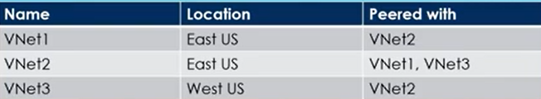

The subscription contains the virtual machines shown in the following table.

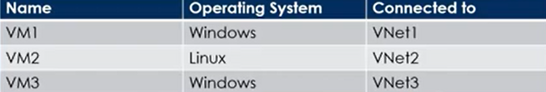

Each Virtual machine contains only a Private IP address. You create an Azure Bastion for VNet1 as

shown in the exhibit:

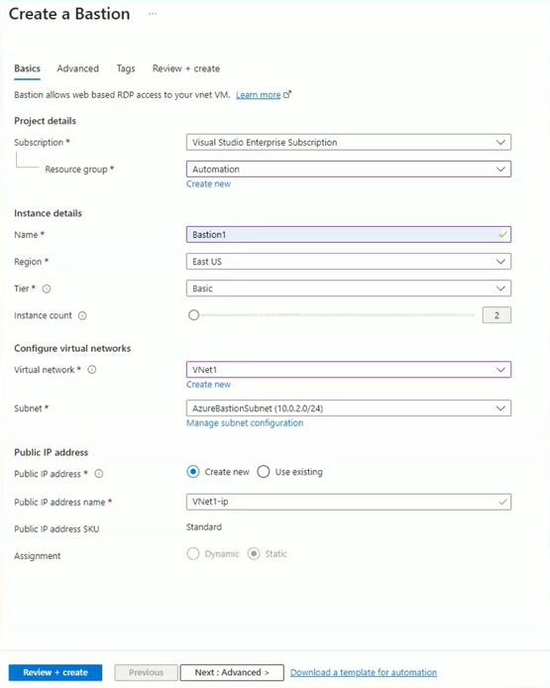

For each of the following statements, select Yes if the statement is true. Otherwise, select No.

**Statement1:**

The remote desktop client (mstsc.exe) can be used to connect to VM1 through Bastion1 Yes/No

**Statement2:**

The Azure portal can use SSH to connect to VM2 through Bastion1 Yes/No

**Statement3:**

The Azure portal can use SSH to connect to VM3 through Bastion1 Yes/No

**185.** You have an Azure subscription. You plan to use an Azure Resource Manager template to deploy a virtual network named VNET1 that will use Azure Bastion.

How should you complete the template?

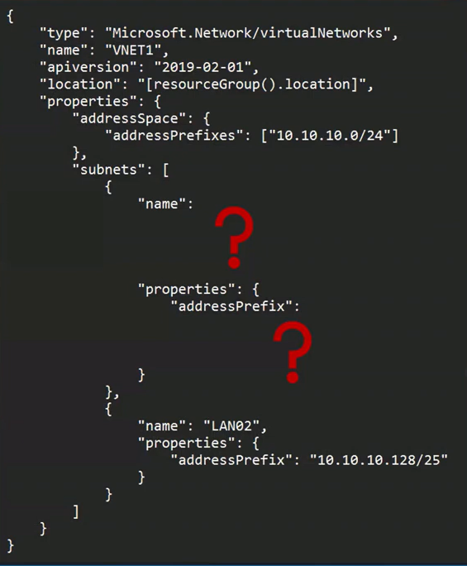

**Name:** 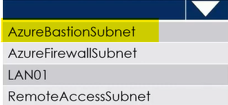

**Subnet:** 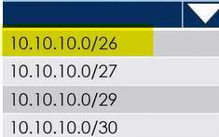

**186.** You have an Microsoft Entra tenant that has the contoso.onmicrosoft.com domain name. You have a domain name of contoso.com registered at a third-party registrar. You need to ensure that you can create Entra ID users that have names containing a suffix of @contoso.com. Which three actions should you perform in sequence? To answer, move the appropriate actions from the list of actions to the answer area and arrange them in the correct order.

|  |  |
| --- | --- |
| **Actions** | **Answer area** |
| Add a record to the public contoso.com DNS Zone. | Add a Custom name. |
| Add an Azure AD tenant. | Add a record to the public contoso.com DNS Zone. |
| Configure company branding. | Verify the domain |
| Create an Azure DNS zone. |  |
| Add a Custom name. |  |
| Verify the domain |  |

**187.** You have a registered DNS domain named contoso.com. You create a public Azure DNS zone named contoso.com. You need to ensure that records created in the contoso.com zone are resolvable from the internet. What should you do?

A. Create NS records in contoso.com.

B. Modify the SOA record in the DNS domain registrar.

C. Create the SOA record in contoso.com.

D. Modify the NS records in the DNS domain registrar.

**188.** You have an Microsoft Entra tenant named contoso.com. You have a CSV file that contains the names and email addresses of 500 external users. You need to create a guest user account in contoso.com for each of the 500 external users.

**Solution:** From Entra ID in the Azure portal, you use the Bulk invite users operation.

Does that meet the goal?

A. Yes

B. No

**189.** You have an Azure subscription named Subscription1 that contains a virtual network VNet1. You add the users in the following table.

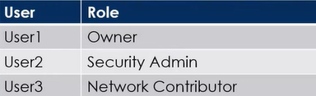

Which user can perform each configuration? To answer, select the appropriate options below:

**Add a subnet to VNet1:** 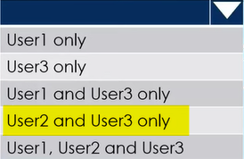

**Assign a user the reader role to VNet1:** 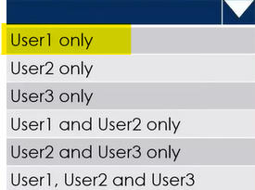

**190.** You have an Azure subscription that contains the following users in a Microsoft Entra tenant named contoso.onmicrosoft.com.

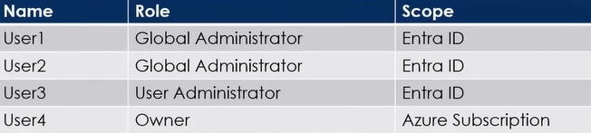

User1 creates a new Entra tenant named external.contoso.onmicrosoft.com. You need to create new user accounts in external.contoso onmicrosoft.com.

**Solution:** You instruct User2 to create the user accounts.

Does that meet the goal?

A. Yes

B. No

**191.** You have two Azure subscriptions named Sub1 and Sub2. An administrator creates a custom role that has an assignable scope to a resource group named RG1 in Sub1. You need to ensure that you can apply the custom role to any resource group in Sub1 and Sub2. The solution must minimize administrative effort. What should you do?

A. Select the custom role and add Sub1 and Sub2 to the assignable scopes. Remove RG1 from the assignable scopes.

B. Create a new custom role for Sub1. Create a new custom role for Sub2. Remove the role from RG1.

C. Create a new custom role for Sub1 and add Sub2 to the assignable scopes. Remove the role from RG1.

D. Select the custom role and add Sub1 to the assignable scopes. Remove RG1 from the assignable scopes. Create a new custom role for Sub2.

**192.** You have an Azure Subscription that contains a storage account named storageacct1234 and two users named User1 and User2. You assign User1 the roles shown in the following exhibit.

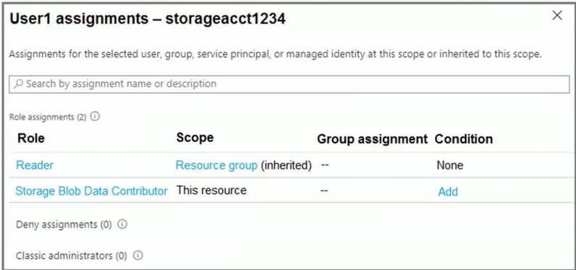

Which two actions can User1 perform? Each correct answer presents a complete solution.

A. Assign roles to User2 for storageacct1234.

B. Upload blob data to storageacct1234.

C. Modify the firewall of storageacct1234.

D. View blob data in storageacct1234.

E. View file shares in storageacct1234.

**193.** You have an Azure subscription that is linked to a Microsoft Entra tenant. The tenant contains the custom role-based access control (RBAC) roles shown in the following table.

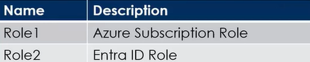

From the Azure portal, you need to create two custom roles named Role3 and Role4. Role3 will be an Azure subscription role. Role4 will be an Entra ID role. Which roles can you clone to create the new roles?

**Role3:** 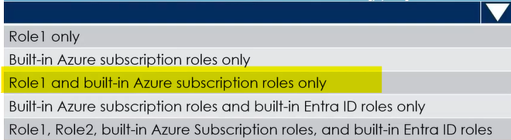

**Role4:** 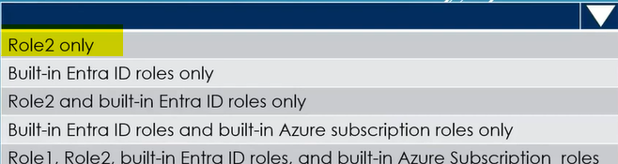

**194.** You have an Microsoft Entra ID tenant named contoso.com. You have a CSV file that contains the names and email addresses of 500 external users. You need to create a guest user account in contoso.com for each of the 500 external users.

**Solution:** You create a PowerShell script that runs the New-MgUser cmdlet for

each external user.

Does this meet the goal?

A. Yes

B. No

<https://learn.microsoft.com/en-us/entra/external-id/b2b-quickstart-invite-powershell>

|  |  |
| --- | --- |
| **195.** You have an Entra ID tenant named  contoso.com. You have two external partner organizations named fabrikam.com and litwareinc.com. Fabrikam.com is configured as a connected organization. You create an  access package as shown in the Access package exhibit. |  |

You configure the external user lifecycle settings as shown in the Lifecycle exhibit.

For each of the following statements, select Yes if the statement is true. Otherwise, select No.

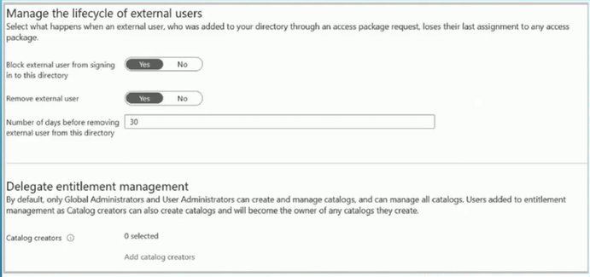

**Statement1:**

litwareinc.com users can be assigned to package1. Yes/No

**Statement2:**

After 365 days, fabrikam.com users will be removed from Group1. Yes/No

**Statement3:**

After 395 days, fabrikam.com users will be removed from the contoso.com tenant. Yes/No

**196.** You have an Azure subscription. You create the following Azure Resource Manager (ARM) template named Template.json

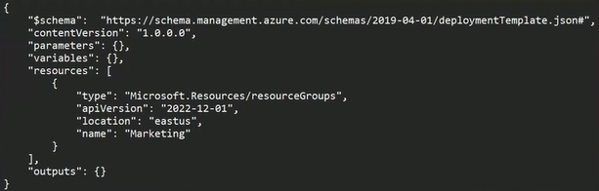

You need to deploy Template.json. Which PowerShell omdlet should you run from Azure Cloud Shell?

A. New-AzDeployment

B. New-AzManagementGroupDeployment

C. New-AzResourceGroupDeployment

D. New-AzTenantDeployment

**197.** You have an Azure subscription that contains the resource groups shown below:

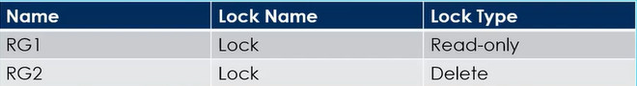

RG1 contains the resources shown in the following table.

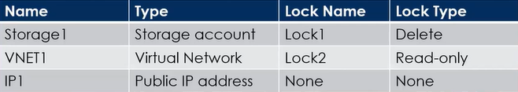

A. None

B. IP1 only

C. IP1 and Storage1 only

D. IP1, VNET1 and Storage1

**198.** You have an Azure subscription named Subscription1. Subscription1 contains a virtual machine named VM1. You install and configure a web server and a DNS server on VM1. VM1 has the effective network security rules shown below:

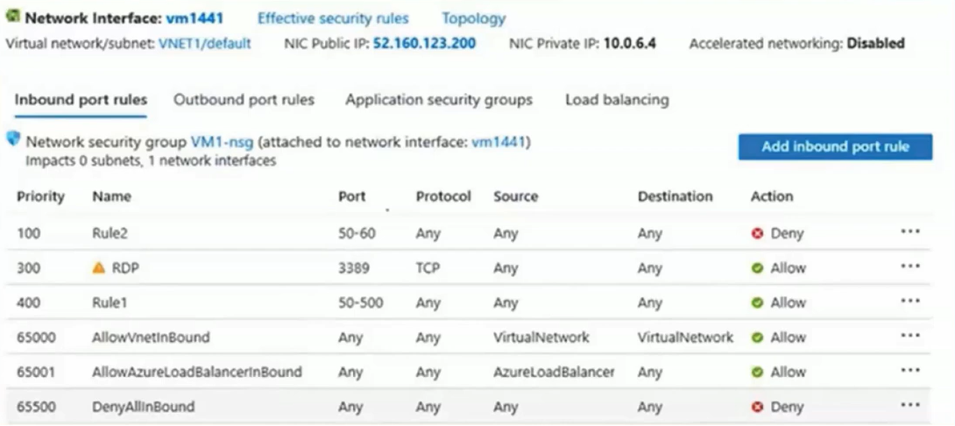

Use the drop-down menus to select the answer choice that completes each statement

based on the information presented in the graphic.

**Internet users:** 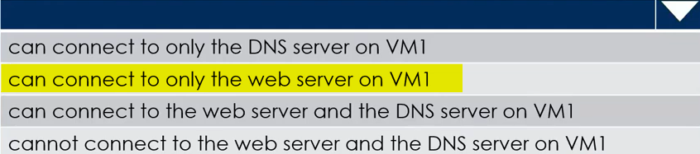

**If you delete Rule 2, Internet users:** 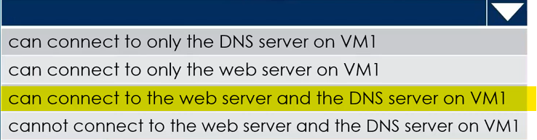

**199.** You have Azure virtual machines that run Windows server 2022 and are configured as shown in following table:

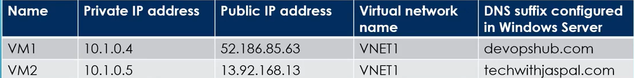

You create a private Azure DNS zone named devopshub.com. You configure the techwithjaspal.com zone to allow auto registration from VNET1. Which A records will be added to the Devopshub.com zone for each virtual machine?

A Records for VM1: 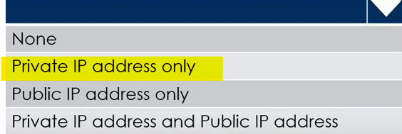

A Recods for VM2: 

**200.** You have an Azure subscription that contains the virtual networks shown in the following table:

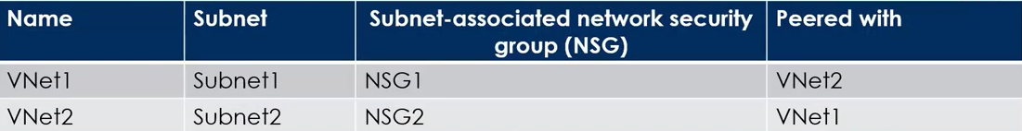

The subscription contains the virtual machines shown in the following table:

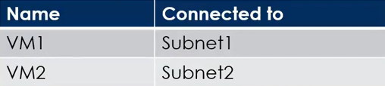

The subscription contains the Azure App Service web apps shown in the following table:

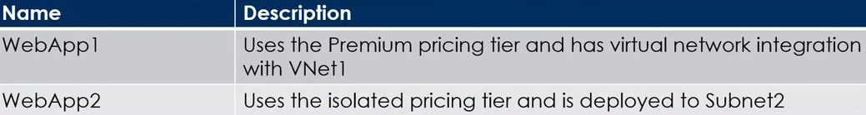

For each of the following statements, select Yes if the statement is true. Otherwise, select No

**Statement1:**

WebApp1 can communicate with VM2. Yes/No

**Statement2:**

NSG1 controls inbound traffic of WebApp1 Yes/No

**Statement3:**

WebApp2 can communicate with VM1. Yes/No

<https://learn.microsoft.com/en-us/azure/app-service/overview-vnet-integration>

**201.** You have an Azure subscription that contains an Azure virtual machine named VM1. VNA

runs a financial reporting app named App1 that does not support multiple active instances. At the end of each month, CPU usage for VM1 peaks when App1 runs. You need to create a scheduled runbook to increase the processor performance of VM1 at the end of each month. What task should you include in the runbook?

A. Add the Azure Performance Diagnostics agent to VM1.

B. Modify the VM size property of VM1.

C. Add VM1 to a scale set.

D. Increase the vCPU quota for the subscription.

E. Add a Desired State Configuration (DSC) extension to VM1.

**202.** You have an Azure subscription that contains a storage account named storage1 in the

North Europe Azure region. You need to ensure that when blob data is added to storage1 a secondary copy is created in the East US region. The solution must minimize administrative effort. What should you configure?

A. operational backup

B. object replication

C. geo-redundant storage (GRS)

D. a lifecycle management rule

**203.** You have an Azure subscription that contains a virtual machine named VM1 and an Azure

function named App1. You need to create an alert rule that will run App1 if VM1 stops. What should you create for the alert rule?

A. an application security group

B. a security group that has dynamic device membership

C. an action group

D. an application group

**204.** You have an Azure subscription that contains an Azure Stream Analytics job named Job. You need to monitor input events for Job1 to identify the number of events that were NOT processed. Which metric should you use?

A. Out-of-Order Events

B. Output Events

C. Late Input Events

D. Backlogged Input Events

<https://learn.microsoft.com/en-us/azure/stream-analytics/stream-analytics-job-metrics>

**205.** You have an Azure subscription named Sub1 that contains the resources shown in the following table

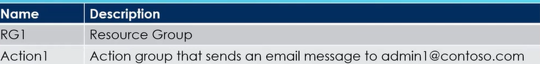

Sub1 contains the following alert rule:

* Name: Alert1
* Scope: All resource groups in Sub1
* Include all future resources
* Condition: All administrative operations
* Actions: Action1

Sub1 contains the following alert processing rule:

* Name: Rule1
* Scope: Sub1
* Rule type: Suppress notifications.
* Apply the rule: On a specific time.
* Start: August 10, 2022
* End: August 13, 2022

For each of the following statements, select Yes if the statement is true. Otherwise, select No.

**Statement1:**

If you create a resource group in Sub1 on August 11,2022, Alert1 is listed in the Azure portal. Yes/No

**Statement2:**

If you create a resource group in Sub1 on August 12,2022, an email message is sent to [admin1@contoso.com](mailto:admin1@contoso.com) Yes/No

**Statement3:**

If you add a tag to RG1 on August 15 2022, an email message is sent to [admin1@contoso.com](mailto:admin1@contoso.com). Yes/No

**206.** You have an Azure subscription that has Traffic Analytics configured. You deploy a new virtual machine named VM1 that has the following settings:

* Region: East US
* Virtual network: VNet1
* NIC network security group: NSG1

You need to monitor VM1 traffic by using Traffic Analytics. Which settings should you configure?

A. Diagnostic settings for VM1

B. NSG flow logs for NSG1

C. Diagnostic settings for NSG1

D. Insights for VM1

**207.** You have an Azure subscription that contains a virtual machine scale set. The scale set contains four instances that have the following configurations:

* Operating system: Windows Server 2019
* Size: Standard_D1_v2

You run the get-azvmss cmdlet as shown in the following exhibit:

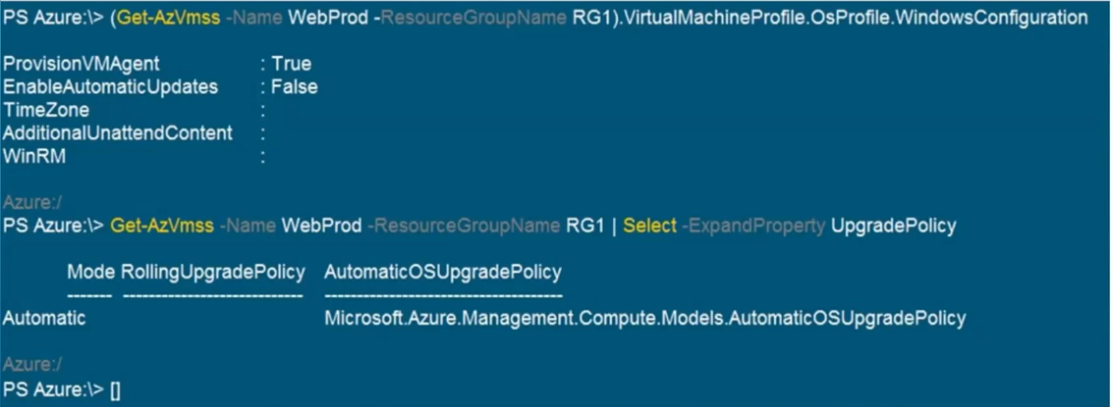

Use the drop-down menus to select the answer choice that completes each statement

based on the information presented in the graphic.

|  |  |
| --- | --- |
| When an administrator changes the virtual machine size, the size will be changed on up to **<answer choice>** virtual machines  simultaneously. |  |
| When a new build of the Windows Server 2019 image is released, the new build will be deployed to up to **<answer choice>** virtual machines simultaneously. |  |

**208.** You plan to create an Azure Storage account named storage1 that will contain a file share named share1. You need to ensure that share1 can support SMB Multichannel. The solution must minimize costs. How should you configure storage?

A. Premium performance with locally-redundant storage (LRS)

B. Standard performance with zone-redundant storage (ZRS)

C. Premium performance with geo-redundant storage (GRS)

D. Standard performance with locally-redundant storage (LRS)

<https://learn.microsoft.com/en-us/azure/storage/files/smb-performance>

**209.** You have an Azure subscription that contains the alerts shown in the following exhibit

|  |  |
| --- | --- |
| Use the drop-down menus to select the answer choice that completes each statement based on the information  presented in the graphic. |  |

**For Alert1, user response:** 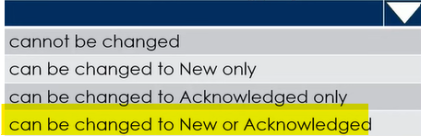

**For Alert2, user response:** 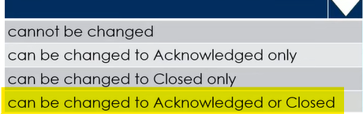

**210.** You have two Azure App Service app named App1 and App2. Each app has a production deployment slot and a test deployment slot. The Backup Configuration settings for the production slots are shown in the following table.

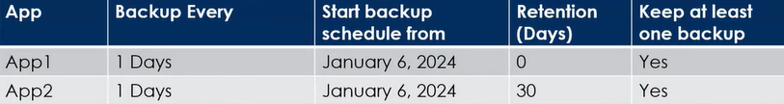

For each of the following statements, select Yes if the statement is true. Otherwise, select No

**Statement1:**

On January 15, 2024, App1 will have only one backup in Storage. Yes/No

**Statement2:**

On February 6, 2024, You can access the backup of the App2 test slot from January 15, 2024 Yes/No

**Statement3:**

On January 15, 2024, You can restore the App2 production slot backup from January 6 to the App2 test slot. Yes/No

**211.** You have an Azure subscription that contains 20 virtual machines, a network security group (NSG) named NSG1, and two virtual networks named VNET1 and VNET2 that are peered. You plan to deploy an Azure Bastion Basic SKU host named Bastion1 to VNET1. You need to configure NSG1 to allow inbound access to the virtual machines via Bastion1. Which port should you configure for the inbound security rule?

A. 22

B. 443

C. 389

D. 8080

<https://learn.microsoft.com/en-us/azure/bastion/bastion-overview>

**212.** You have a Microsoft Entra tenant named contoso.onmicrosoft.com that contains the users shown in the following table.

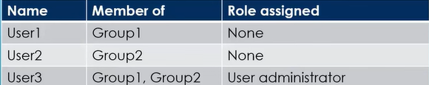

You enable password reset for contoso.onmicrosoft.com as shown in the Password Reset exhibit below:

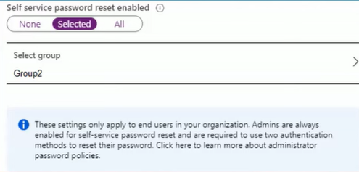

|  |  |
| --- | --- |
| You configure the authentication methods for password reset as shown in the Authentication Methods exhibit.  For each of the following statements, select Yes if the statement is true. Otherwise,  select No |  |
| **Statement1:**  After User2 answers three Security questions correctly, he can reset his password immediately.  Yes/No |
| **Statement2:**  If User1 forgets her password, she can reset the password by using the mobile phone app.  Yes/No |
| **Statement3:**  User3 can add security questions to the password reset process.  Yes/No |

**213.** You manage a virtual network named VNet1 that is hosted in the East US Azure

region. VNet1 hosts two virtual machines named VM1 and VM2 that run Windows Server. You need to inspect all the network traffic from VM1 to VM2 for a period of three hours.

**Solution:** From Performance Monitor, you create a Data Collector Set (DCS).

Does this meet the goal?

A. Yes

B. No

**214.** You have an Azure subscription that contains a virtual machine named VM1. You plan to deploy an Azure Monitor alert rule that will trigger an alert when CPU usage on VM1 exceeds 80 percent. You need to ensure that the alert rule sends an email message to two users named User1 and User2. What should you create for Azure Monitor?

A. an action group

B. a mail-enabled security group

C. a distribution group

D. a Microsoft 365 group

**215.** You have an Azure Storage account that contains 5,000 blobs accessed by multiple users. You need to ensure that the users can view only specific blobs based on blob index tags. What should you include in the solution?

A. a role assignment condition

B. a stored access policy

C. just-in-time (JIT) VM access

D. a shared access signature (SAS)

<https://learn.microsoft.com/en-us/azure/storage/blobs/storage-auth-abac-portal>

**216.** You are developing a sales application that will contain several Azure cloud services and handle different components of a transaction. Different cloud services will process customer orders, billing, payment, inventory, and shipping. You need to recommend a solution to enable the cloud services to asynchronously communicate transaction information by using XML messages.

What should you include in the recommendation?

A. Azure Application Gateway

B. Azure Queue Storage

C. Azure Data Lake

D. Azure Traffic Manager

**217.** You have two Azure subscriptions named Sub1 and Sub2. Sub1 contains a virtual machine named VM1 and a storage account named storage1. VM1 is associated to the resources shown in the following table.

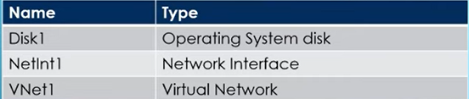

You need to move VM1 to Sub2. Which resources should you move to Sub2?

A. VM1, Disk1, and NetInt1 only

B. VM1, Disk1, and VNet1 only

C. VM1, Disk1, and storage1 only

D. VM1, Disk1, Netlnt1, and VNet1

**218.** You have an Azure web app named App1. You need to monitor the availability of App1 by using Custom Availability Sets . What should you use in Azure Monitor?

A. Azure Service Health

B. Azure Application Insights

C. the Diagnostic settings

D. metrics

**219.** You have a Microsoft Entra tenant that is linked to 10 Azure subscriptions. You need to centrally monitor user activity across all the subscriptions. What should you use?

A. Azure Application Insights Profiler

B. access reviews

C. Activity log filters

D. a Log Analytics workspace

|  |  |
| --- | --- |
| **220.** You have an Azure subscription. The subscription contains a virtual machine that runs Windows 11. You need to join the virtual machine to a Microsoft Entra ID. How should you complete the Azure Resource Manager (ARM) template? |  |
| **1st Question mark:** |
| **2nd Question mark:** |  |

**221.** Your company has a Microsoft SQL Server Always On availability group configured on their Azure virtual machines (VMs). You need to configure an Azure internal load balancer as a listener for the availability group.

**Solution:** You set Session persistence to Client IP.

Does the solution meet the goal?

A. Yes

B. No

**222.** You have an Azure subscription that contains the resources shown in the following

table.

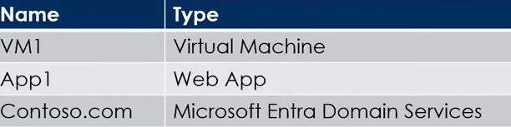

All the resources connect to a virtual network named VNet1. You plan to deploy an Azure Bastion host named Bastion1 to VNet1. Which resources can be protected by using Bastion1?

A. VM1 only

B. contoso.com only

C. App1 & contoso.com only

D. VM1 & contoso.com only

E. VM1, App1 & contoso.com

**223.** You have an Azure virtual machine named VM1 that runs Windows Server 2016. You need to create an alert in Azure when more than two error events are logged to the System event log on VM1 within an hour.

**Solution:** You create an Azure storage account and configure shared access signatures (SASs). You install the Microsoft Monitoring Agent on VM1.You create an alert in Azure Monitor and specify the storage account as the source.

Does this meet the goal?

A. Yes

B. No

**224.** You have an on-premises network. You have an Azure subscription that contains three virtual networks named VNET1, VNET2 and VNET3. The virtual networks are peered and connected to the on-premises network. The subscription contains the virtual machines shown in the following table.

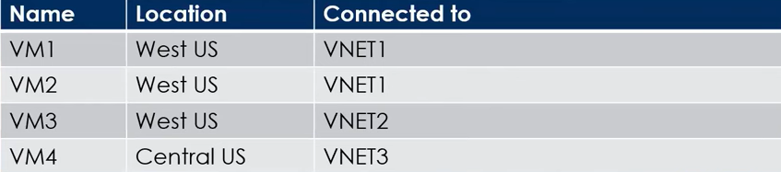

You need to monitor connectivity between the virtual machines and the on-premises network by using Connection Monitor. What is the minimum number of connection monitors you should deploy?

A. 1

B. 2

C. 3

D. 4

**226.** You have an Azure subscription named Subscription1 that contains the resources shown in the following table.

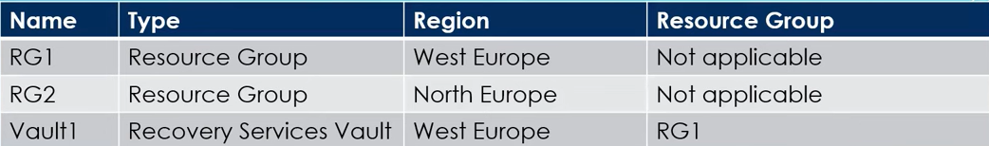

You create virtual machines in Subscription1 as shown in the following table:

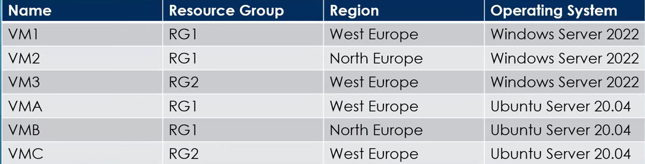

You plan to use Vault1 for the backup of as many virtual machines as possible. Which virtual machines can be backed up to Vault1?

A. VM1 only

B. VM3 and VMC only

C. VM1, VM2, VM3, VMA, VMB and VMC

D. VM1, VM3, VMA and VMC only

E. VM1 and VM3 only

**227.** A company has the following resources defined as part of their Azure subscription.

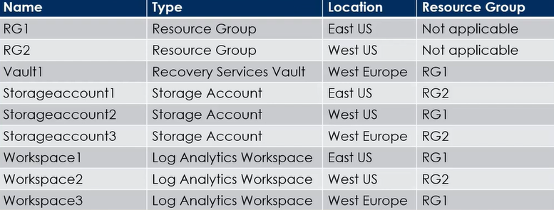

The company is planning to configure the Diagnostic settings for the Recovery Services vault to store the Azure Backup Reports.

Which of the following Log Analytics workspaces can be used to store the backup

reports?

A. Workspace1 only

B. Workspace2 only

C. Workspace3 only

D. Workspace1, Workspace2 & Workspace3

**228.** Your company has an Azure storage account named storage1 that has the following properties.

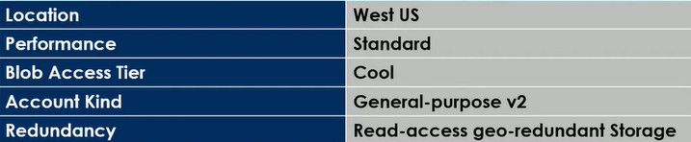

The company wants to change the redundancy configuration of storage account from Read-access geo-redundant storage to Zone redundant storage by requesting Azure support for live migration. Which of the following must be carried out first to fulfill this requirement?

A. Ensure to change the performance of the storage account

B. Ensure to change the Access tier of the storage account

C. Ensure to change the Account kind of the storage account

D. Ensure to change the Redundancy of the storage account to Locally redundant Storage (LRS)

**229.** You have an app named App1 that is installed on two Azure virtual machines named VM1 and VM2. Connections to App1 are managed by using an Azure Load Balancer. The effective network security configurations for VM2 are shown in the following exhibit.

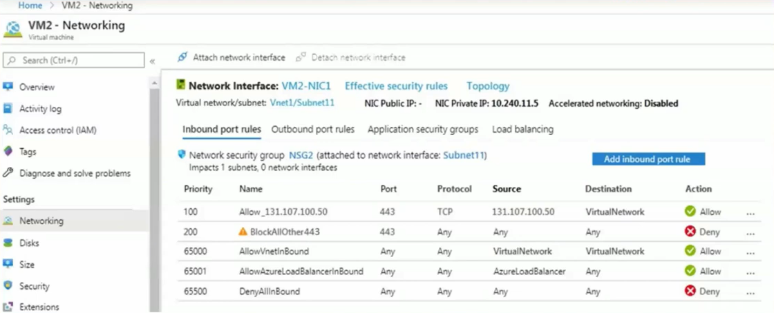

You discover that connections to App1 from 131.107.100.50 over TCP port 443 fail. You verify that the Load Balancer rules are configured correctly. You need to ensure that connections to App1 can be established successfully from 131.107.100.50 over TCP port 443.

**Solution:** You delete the BlockAlIOther443 inbound Security rule.

Does this meet the goal?

A. Yes

B. No

**230.** You need to ensure that a Microsoft Entra user named Admin1 is assigned the required role to enable Traffic Analytics for an Azure subscription.

**Solution:** You assign the Network Contributor role at the subscription level to Admin1.

Does this meet the goal?

A. Yes

B. No

**231.** You have an Azure subscription that contains the resources shown in the following table.

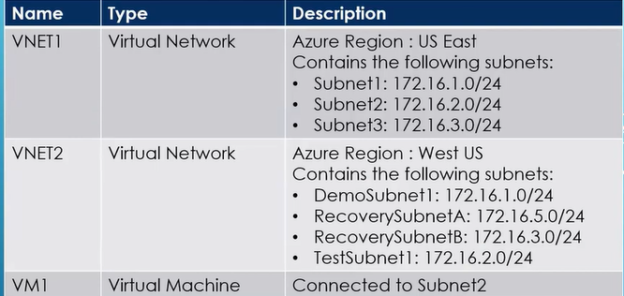

You configure Azure Site Recovery to replicate VM1 between the US East and West US regions. You perform a test failøver of VM1 and specify VNET2 as the target virtual network. When the test version of VM1 is created, to which subnet will the virtual machine be connected?

A. TestSubnet1

B. DemoSubnet1

C. RecoverySubnetA

D. RecoverySubnetB

**232.** You have an Azure subscription. You need to deploy a virtual machine by using a Azure Resource Manager (ARM) template. How should you complete the template?

|  |  |
| --- | --- |
| **1st Question mark:** |  |
| **2nd Question mark:** |

**233.** Your team needs to deploy an Azure Resource Manager template. This template would be used to deploy 10 Azure Web Apps. The team wants to ensure the required resources are present in Azure before the deployment of the template. The implementation needs to minimize costs as much as possible. Which of the following would the team need to deploy as a pre-requisite?

A. 1 Azure Application Gateway

B. 1 Azure Load Balancer

C. 1 App Service Plan

D. 10 App Service Plans

**234.** You have an Azure subscription that contains the resources shown in the following table.

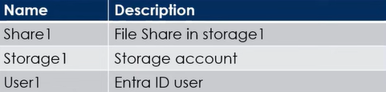

You need to assign User1 the Storage File Data SMB Share Contributor role for share1. What should you do first?

A. Enable identity-based data access for the file shares in storage1.

B. Modify the security profile for the file shares in storage1.

C. Select Default to Microsoft Entra authorization in the Azure portal for storage1.

D. Configure Access control (IAM) for share1.

|  |  |
| --- | --- |
| **235.** You have a Microsoft Entra tenant. You need to modify the Default user role permissions settings for the tenant. The solution must meet the following requirements:   * Standard users must be prevented from creating new service principals. * Standard users must only be able to use PowerShell or Microsoft Graph to manage their own Azure resources.   Which two settings should you modify? |  |

**236.** You have an Azure subscription that contains an Microsoft Entra tenant named contoso.com. The tenant is synced to the on-premises Active Directory domain. The domain contains the users shown in the following table.

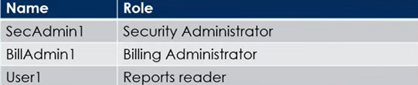

You enable self-service password reset (SSPR) for all users and configure SSPR to have the following authentication methods:

* Number of methods required to reset: 2
* Methods available to users: Mobile phone, Security questions
* Number of questions required to register: 3
* Number of questions required to reset: 3

You select the following security questions;

* What is your Favorite food?
* In what city was your first job?
* What was the name of your first pet?

For each of the following statements, select Yes if the statement is true. Otherwise, select No

**Statement1:**

SecAdmin1 must answer the following question during the self-service password reset:

In what city was your first job? Yes/No

**Statement2:**

BillAdmin1 must answer the following question during the self-service password reset:

What is your Favorite food? Yes/No

**Statement3:**

User1 must answer the following question during the self-service password reset:

What was the name of your first pet? Yes/No

**237.** You deploy Azure virtual machines to three Azure regions. Each region contains a virtual network. Each virtual network contains multiple subnets peered in a full mesh topology. Each subnet contains a network security group (NSG) that has defined rules. A user reports that he cannot use port 33000 to connect from a virtual machine in one region to a virtual machine in another region. Which two options can you use to diagnose the issue?

A. Azure Virtual Network Manager

B. IP flow verify

C. Azure Monitor Network Insights

D. Connection troubleshoot.

E. elective security rules

**238.** You have an Azure subscription that has diagnostic logging enabled and is configured to send logs to a Log Analytics workspace. You are investigating a service outage. You need to view the event time, the event name, and the affected resources. How should you complete the query?

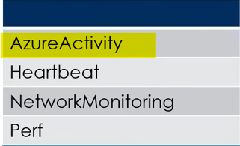 | Where Level == 'Critical'

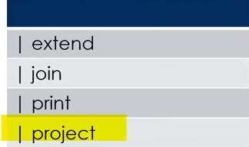 TimeGenerated, OperationNameValue, Resourceld

**239.** You have an app named App1 that is installed on two Azure virtual machines named VM1 and VM2. Connections to App1 are managed by using an Azure Load Balancer. The effective network security configurations for VM2 are shown in the following exhibit.



You discover that connections to App1 from 131.107.100.50 over TCP port 443 fail. You verify that the Load Balancer rules are configured correctly. You need to ensure that connections to App1 can be established successfully from 131.107.100.50 over TCP port 443.

**Solution:** You create an inbound security rule that allows any traffic from the Azure Load Balancer source and has a priority of 150.

Does this meet the goal?

A. Yes

B. No

**240.** You have an Azure virtual machine named VM1. You use Azure Backup to create a

backup of VM1 named Backup1. After creating Backup1, you perform the following changes to VM1:

* Modify the size of VM1.
* Copy a file named Budget.xls to a folder named Data.
* Reset the password for the built-in administrator account.
* Add a data disk to VM1.

An administrator uses the Replace existing option to restore VM1 from Backup1. You need to ensure that all the changes to VM1 are restored. Which change should you perform again?

A. Modify the size of VM1.

B. Reset the password for the built-in administrator account.

C. Add a data disk.

D. Copy Budget.xls to Data.

**241.** You need to ensure that a Microsoft Entra ID user named Admin1 is assigned the required role to enable Traffic Analytics for an Azure subscription.

**Solution:** You assign the Owner role at the subscription level to Admin1.

Does this meet the goal?

A. Yes

B. No

**242.** You have an Azure subscription that is used by four departments in your company. The subscription contains 10 resource groups. Each department uses resources in several resource groups. You need to send a report to the finance department. The report must detail the costs for each department. Which three actions should you perform in sequence?

1. Assign a tag to each resource group.

2. Assign a tag to each resource. **1**

3. Download the usage report. **3**

4. From the Cost analysis blade, filter the view by tag. **2**

5. Open the Resource costs blade of each resource group.

**243.** You have the Azure management groups shown in the following table:

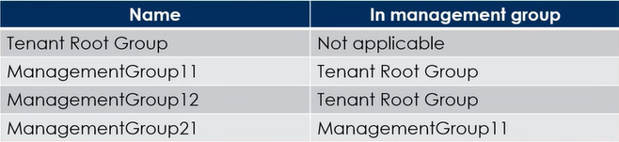

You add Azure subscriptions to the management groups as shown in the following table:

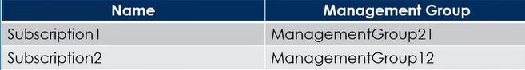

You create the Azure policies shown in the following table:

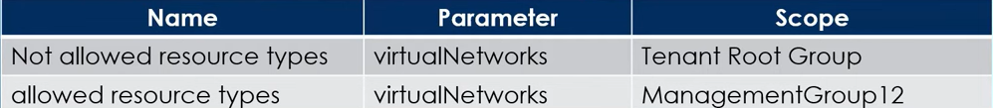

For each of the following statements, select Yes if the statement is true. Otherwise, select No.

**Statement1:**

You can create a virtual network in subscription1. Yes/No

**Statement2:**

You can create a virtual machine in subscription2. Yes/No

**Statement3:**

You can add subscription1 to ManagementGroup11. Yes/No

**244.** You have an Azure App Service web app named App1. You need to collect performance traces for App1. What should you use?

A. Azure Application Insights Profiler

B. the Activity log

C. the Deployment center

D. the Diagnose and solve problems settings.

**245.** You have an Azure subscription that contains an Azure SQL database named DB1. You plan to use Azure Monitor to monitor the performance of DB1. You must be able to run queries to analyze log data. Which destination should you configure in the Diagnostic settings of DB1?

A. Send to a Log Analytics workspace.

B. Archive to a storage account.

C. Stream to an Azure event hub.

**246.** You have an Azure subscription. The subscription contains virtual machines that run Windows Server. You have a data collection rule (DCR) named Rule1. You plan to use the Azure Monitor Agent to collect events from Windows System event logs. You only need to collect system events that have an ID of 1001. Which type of query should you use for the data source in Rule1?

A. SQL

B. XPath

C. KQL

**247.** True or false: Microsoft ExpressRoute is a virtual networking technology that operates over the public Internet that allows secure, scalable access to Microsoft Azure services while ensuring performance, security, and reliability.

False

**248.** A company has an Azure AD tenant. They have users that are also synced with their onpremise environment. Getcloudskillsusr1 has the Reports Reader role assigned. The administrator has enabled self-service password reset (SSPR) for all users.

- The administrator has enabled the following SSPR settings:

- Number of methods required to reset - 2

- Methods available to users - Mobile phone and Security questions

- Number of questions to register - 3

- Number of questions to reset – 3

The following security questions are chosen:

- In what city was your first job?

- What was the name of the first school you attended?

Would Getcloudskillsusr1 be required to answer the security question "In what city was your first job?" to reset their password?

Yes/No

**249.** Imagine your company has the following storage accounts in place as part of its Azure subscription:

- General Purpose V1

- General Purpose V2

- Blob Storage

Which of the following storage account/accounts could be used to store objects as part of the Archive tier?

1. General Purpose V1 only
2. General Purpose V2 only
3. All Storage accounts
4. General Purpose V1 and Blob Storage only
5. Blob Storage only
6. General Purpose V2 and Blob Storage only
7. General Purpose V1 and General Purpose V2 only

**250.** You need to deploy two Azure virtual machines named VM1 and VM2 based on the Windows server 2016

image. The deployment must meet the following requirements:

- Provide a Service Level Agreement (SLA) of 99.95 percent availability.

- Use managed disks.

You propose a solution to create a scale set for the requirement. Would the solution meet the goal?

Yes/No

**251.** A company has the following App Service Plans defined as part of their Azure subscription:

* Plan1 runs Linux in East US.
* Plan2 runs Windows in East US.
* Plan 3 runs Windows in UK South.

The company is planning on deploying the following Azure Web App Instances:

- App1 runs on runtime stack .Net Core 3.1 in East us.

- App2 runs on runtime stack ASP.NET v4.7 in East us.

Which of the following App service plans can you use for App1?

1. Plan1, Plan2 and Plan 3
2. Plan2 and Plan 3 only
3. Plan2 only
4. Plan1 and Plan2 only
5. Plan1 only

**252.** You create Azure AD administrative units for the subsidiaries of your organization. Each of the subsidiaries includes several hundred employees. You need to add these employees as administrative unit members.

Select the tool you can use to achieve your goal.

1. Microsoft Office Admin center
2. PowerShell
3. Azure AD Portal
4. Microsoft Graph
5. Azure CLI

**253.** You need to allow traffic onto certain FQDN's via the Azure Firewall. Which of the following rules would you create for this requirement?

A. Network collection rules

B. FQDN collection rules

C. Application collection rules

D.NAT collections rules

**254.** A company has set up an Azure subscription and a tenant. They want to ensure that only Virtual Machines of a particular SKU size can be created in their Azure account.

They decide to implement Role-Based Access Control.

Does this fulfill the requirement?

Yes/No

**255.** You create an App Service plan B1 for your web app. You want Azure to be able to add up to 10 VM instances to run your app automatically during the highest traffic on your site. What are two configuration options you should implement to achieve your goal in the most cost-effective

way?

A. Scale up the service plan to P1

B. Scale out based on a schedule

C. Scale out the service plan to P1

D. Scale up based on a metric

E. Scale up the service plan to S1

F. Scale up based on a schedule

G. Scale out the service plan to S1

H. Scale-out based on a metric

**256.** A company is planning to deploy an application to a set of Virtual Machines in an Azure network. The company needs to have an SLA of 99.999% for the application hosted on the Virtual machines. Which of the following should be implemented to guarantee an SLA of 99.999% on the infrastructure level?

A. Deploy single virtual machines across multiple regions.

B. Make the virtual machines part of an availability set.

C. Deploy the virtual machines in an availability zone across multiple regions

D. Assign a standard public IP address to the virtual machines.

**257.** Which of the following needs to be implemented on the Azure virtual network to deploy the Azure Bastion Host?

A. Add a service endpoint.

B. Add a new subnet.

C. Enable DDoS protection for the virtual network.

D. Add a new address space.

**258.** What benefit does a Content Delivery Network (CDN) provide its users?

A. Allows you to store data that can be retrieved later in an extremely fast and inexpensive manner

B. Allows you to keep temporarily session information on the web visitor such as their login ID or their name.

C. For a small fee, Azure will take over management of your virtual machine, perform OS updates and ensure it's running well.

D. Allows you to reduce the traffic coming into a web server for static, unchanging files such as images, videos, and PDFs.

**259.** A company has started using Azure and set up a subscription. They want to see the costs being incurred for each type of resource. Which of the following can help you get these details?

A. Go to your Azure AD directory and go to Licences.

B. Go to your Subscription and go to Cost Analysis.

C. Go to your Subscription and go to Resource Groups.

D. Go to your Azure AD directory and go to Cost Analysis.

**260.** A company has an application deployed across a set of virtual machines. Users connect to the application either using point-to-site VPN or site-to-site VPN connections. You need to ensure that connections to the application are spread across all of the virtual machines. Which of the following could you set up for this requirement? Choose 2 answers from the options given below.

A. A Public Load Balancer

B. An Internal Load Balancer

C. An Azure Content Delivery Network

D. An Azure Application Gateway

E. A Traffic Manager Profile

**261.** A file named audio.log has been uploaded to a Storage account container called demo. You need to allow users to download the object. The access should be granted for a day only. You need to provide a secure way to access the object. Which of the following would you implement for this purpose?

A. Mark public access on the object.

B. Provide access Keys.

C. Generate a shared access signature.

D. Mark public access on the container.

**262.** What does Azure DNS allow you to do?

A. Manage the security and access to your website.

B. Register new domain names, removing the need to use a domain registrar.

C. Manage and host your registered domain and associated records.

**263.** Your company has an Azure subscription. In the subscription, you create an Azure file share named share1. You also create a shared access signature (SAS) named SASdemo as shown in the following exhibit:

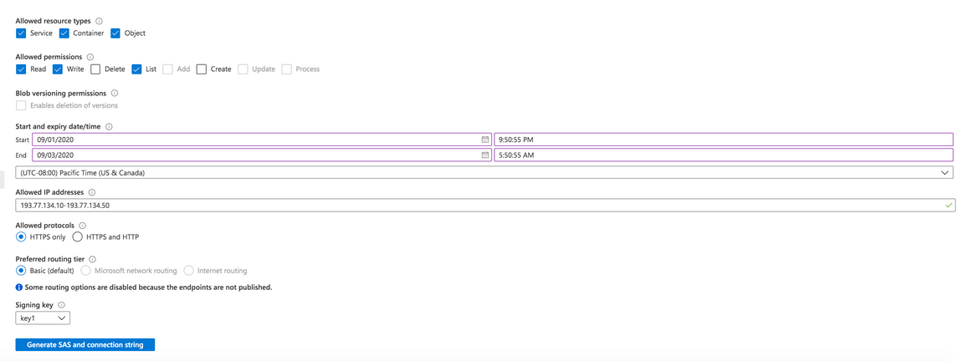

If you run Microsoft Azure Storage Explorer on a computer that has an IP address of 193.77.134.1, and you use SASdemo to connect to the storage account, then you ...

A. will have no access.

B. will be prompted for the credentials.

C. will have read, write and list access.

D. will have read-only access.

**264.** If no rules other than the default NSG rules are in place, are VM's on SubnetA and SubnetB be able to connect to the Internet?

Yes/No

**265.** In order to use ARM templates in automation, what other file is usually required besides the ARM template JSON file itself?

A. The parameter JSON file

B. The parameter XML file

C. A .PS1 PowerShell script file

D. A .SH file to contain the Shell Script in CLI

E. No other files are required. But a parameter JSON file would be used if the template had parameters as inputs.

**266.** You have defined an autoscale condition with four autoscale rules. The first rule scales out when the CPU utilization reaches 70 percent. The second rule scales back in when the CPU utilization drops below 50 percent. The third rule scales out if memory occupancy exceeds 75 percent. The fourth rule scales back in when memory occupancy falls below 50 percent. When will the system scale out?

A. When CPU utilization reaches 70 percent, or memory occupancy exceeds 75 percent

B. When CPU utilization reaches 70 percent, and memory occupancy exceeds 75 percent

C. You can't do this with a single autoscale condition. An autoscale condition can only contain

autoscale rules that use the same metric

**267.** A company has set up a Load balancer that load balances traffic on ports 80 and 443 across 3 virtual machines. You have to ensure that all RDP traffic is directed towards a VM named getcloudskillsvm. How would you achieve this?

A. By creating a new internal load balancer for getcloudskillsvm

B. By creating a new public load balancer for getcloudskillsvm

C. By creating an inbound NAT rule

D. By creating a new IP configuration

268. In order to get diagnostics from an Azure virtual machine you own, what is the first step to doing that?

A. You need to grant RBAC permissions to the user requesting diagnostics

B. A diagnostics agent needs to be installed on the VM

C. You need to create a storage account to store it

**269.** In your company, all virtual networks are hosting virtual machines with varying workloads. A virtual machine named getcloudskillsvm is hosted in Vnet getcloudskills-vnet1. This virtual machine will have intrusion detection software installed on it. All traffic on all other virtual networks must be routed via this virtual machine.

You need to complete the required steps for implementing this requirement.

Which of the following would you need to create additional to ensure that traffic is sent via the virtual machine hosting the intrusion software?

A. Add DNS servers

B. Add a service endpoint

C. Add an address space

D. A new route table

**270.** Which of the following would you implement for the below requirement?

*All web servers need to be protected from SQL injection attacks.*

A. An Internal Load Balancer

B. An application gateway with a WAF

C. A network security group

D. A Public Load Balancer

**271.** A company has a requirement to retain any blob data that might accidentally be deleted. The deleted data needs to be retained for 14 days. From which of the following section of the Storage account would you modify to fulfill this requirement?

A. Soft Delete

B. Advanced security

C. Firewall and virtual networks

D. Lifecycle Management

**272.** Which of the following network watcher feature would you use for the following requirement?

*Find out if there is outbound connectivity between an Azure virtual machine and an external host.*

A. Traffic Analytics

B. Connection Monitor

C. IP Flow Verify

D. Next Hop

**273.**  You need to connect Azure resources like Azure virtual machines across geographical regions. Which Azure networking option should you use?

A. Virtual network peering

B. Azure ExpressRoute

C. VPN Gateway

**274.** Which Azure Service is the centralized spot for all Activity Logs, Metrics, Alerts, and Diagnostics for all resources across your subscription?

A. Event Hub

B. Azure Log Analytics

C. Azure Stream Analytics

D. Azure Monitor

**275.** You have an application in the East US region, running on a virtual network also in the East US region. You need to establish an encrypted, private connection to a data source that exists in Azure's Japan region, and that data source does not have a public endpoint. Attempting to connect with the Japanese data source from East US results in an error. What is the best way to establish a connection between the two regions?

A. Use Global VNet Peering.

B. Install a Network Gateway in the Japan region. And have the East US application establish a

private point-to-site VPN to Japan.

C. Install Gateway devices in both the East US and Japan regions, and connect the gateways

together.

**276.** Which of the following needs to be set up in Azure for the Site-to-Site VPN connection?

A. An additional address space for the Virtual Network

B. A service endpoint

C. A gateway subnet

D. A gateway Virtual Machine

**277.** Which of the following can be used to organize resources for cost reporting? Choose the most complete answer.

A. Subscriptions, resource groups, and tags

B. Cost Center, subscriptions, resource groups, and tags

C. Tags

D. Resource groups and tags

**278.** Your company has an Azure AD tenant named getcloudskills.com.

The following user is part of the tenant:

- Getcloudskillsusr1 is a User administrator.

The following VM is part of the tenant:

- Getclouskillsvm1 is a Windows 10 device that is AAD registered.

The following group is part of the tenant:

- Getcloudskillsgroup1 is a Dynamic Device group, Getcloudskillsusr1 is an owner of that group.

Would user Getcloudskillsusr1 be able to add device Getclouskillsvm1 to group Getcloudskillsgroup1?

Yes/No

**279.** Users are reporting that when they attempt to access myapps.microsoft.com, they are prompted multiple times to sign in and are forced to use an account name that ends with onmicrosoft.com. You discover that there is a UPN mismatch between Azure AD and the on-premises Active Directory. You need to ensure that the users can use single-sign-on (SSO) to access Azure resources. What should you do first?

A. From Azure AD, add and verify a custom domain name.

B. From the on-premises network, request a new certificate that contains the Active Directory

domain name.

C. From the on-premises network, deploy Active Directory Federation Services in a clustered

environment.

**280.** A new Network interface named Secondary has been created. The Network interface needs to be added to the Virtual machine. What must be done first in order to ensure that the network interface can be attached to the Virtual Machine?

A. The primary network interface needs to be removed

B. The public IP needs to be deallocated from the primary network interface

C. The machine needs to be stopped first

**281.** In the context of alerts, you can create an Action Group. Which of the following is not an Action Type that can exist inside an Action Group?

A. Logic App

B. SMS text message

C. Facebook Messenger message

D. Azure Function

**282.** You have an Azure subscription named Getcloudskillsstaging. Under the subscription, you create a Resource group named Getcloudskillsrg. You then create an Azure policy based on the "Not allowed resources types" definition. You define the parameters as Microsoft.Network. virtual networks as the not allowed resource type. You assign this policy to the Tenant Root Group. A Virtual Network does not already exist in this subscription.

Would you be able to create a virtual machine in the Getcloudskillsrg Resource group?

Yes/No

**283.** Select all true statements that apply to the use of Azure Disk Encryption (ADE) for Windows Azure VM disk protection.

A. ADE uses DM-Crypt for Linux-based VMs.

B. ADE is integrated with Azure Key Vault.

C. ADE encrypts all data at rest and in transit.

D. ADE encrypted VM can be backed up to the Recovery Service Vault.

E. ADE supports the encryption of Basic tier VM's.

F. ADE can use Azure Key Vault and Azure Recovery Service Vault from different Azure regions.

G. ADE uses BitLocker for Windows VM-controlled disks.

H. ADE uses DM-Crypt for Windows VM-controlled disks.

**284.** Your Azure subscription contains 10 virtual machines. You need to enable alerts if any virtual machine restarts, stops, or delocalizes. Alerts must be sent to three administrators by email and Azure App push notifications.

You need to create alert rules, action groups, and actions in the Azure portal.

What are the minimum number of alert rules, action groups, and actions you should create?

A. Alert Rules = 3; Action groups = 1; Actions = 3

B. Alert Rules = 1; Action groups = 1; Actions = 1

C. Alert Rules = 2; Action groups = 3; Actions = 1

D. Alert Rules = 3; Action groups = 1; Actions = 1

**285.** You have an Azure Storage account that contains a blob container - container4626.

You need to configure access to container4626. Which authorization types can be used.?

A. Azure AD only

B. Storage key or SAS only.

C. Azure AD, shared access signature (SAS) or storage key only.

D. Azure AD, shared access signature (SAS) or certificate only.

**286.** You need to create a DNS record set with the relative name www in DNS Zone contoso.com. Fully qualified domain name of the record set will be www.contoso.com.

Record Type is 'A' and TTL is 3600 seconds. Record set contains a single record set with IP Address

'1.2.3.4'.

Complete the PowerShell cmdlet.

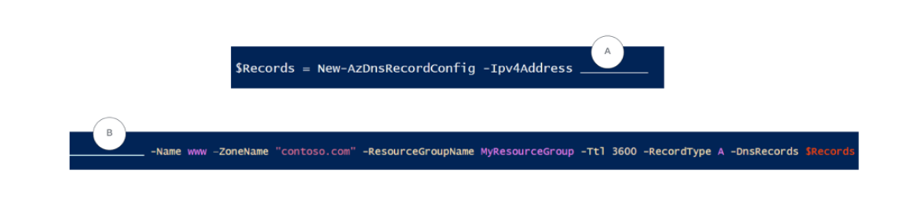

A. A = "1.2.3.4", B = New-AzDnsRecordSet

B. A = "192.168.1.4", B = New-AzDnsRecordSet

C. A = "1.2.3.4", B = New-AzDnsRecordconfig

D. A="1.2.3.4", B = New-AzDnsZone

**287.** The policy must be configured to require members of the Global Administrators group to use multi-factor authentication and an Azure AD-joined device when they connect to Azure AD from untrusted locations.

**Solution:** You can access the multi-factor authentication page to alter the user settings. Does the solution meet the goal?

Yes/No

**288.** Your company has an Azure Active Directory (Azure AD) subscription. You need to deploy five virtual machines (VMs) to your company's virtual network subnet. The VMs will each have both a public and private IP address. Inbound and outbound security rules for all of these virtual machines must be identical. Which of the following is the least number of security groups needed for this configuration?

A. 2

B. 1

C. 4

D. 3

**289.** Which PowerShell cmdlet allows you to create a new Virtual machine scale set?

A. Set-AzVmss

B. New-AzVM

C. New-AzVmss

**290.** You have migrated your on-premises web application to the Azure web app, prod-webapp. After migration, it has been observed that the website is not accessible using the old domain name, https:// [www.cloudfinanceportal.com](http://www.cloudfinanceportal.com). You need to configure DNS to resolve this issue.

Which two DNS records are needed to resolve this issue?

A. Create Name server (NS) record and map it to IP address of prod-webapp.

B. Create PTR record and map it to prod-webapp.azurewebsites.net.

C. Create A record and map it to IP address of prod-webapp.

D. Create CNAME record and map it to prod-webapp.azurewebsites.net.

**291.** You have an administrative unit - Chicago. Below users and groups are added to administrative unit - Chicago.

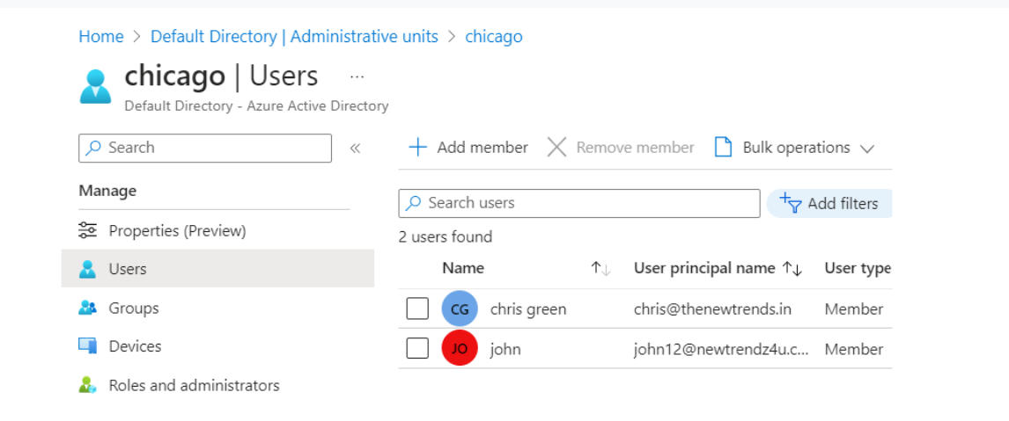

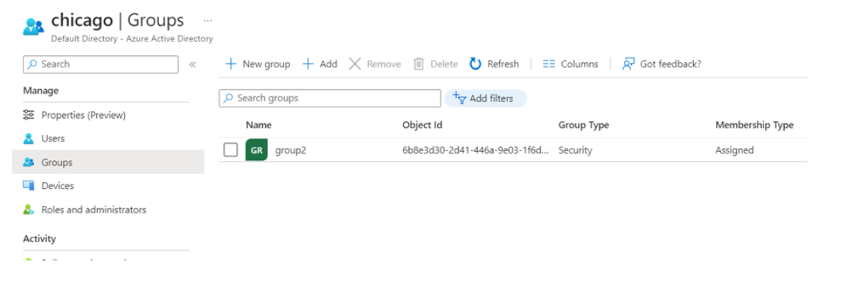

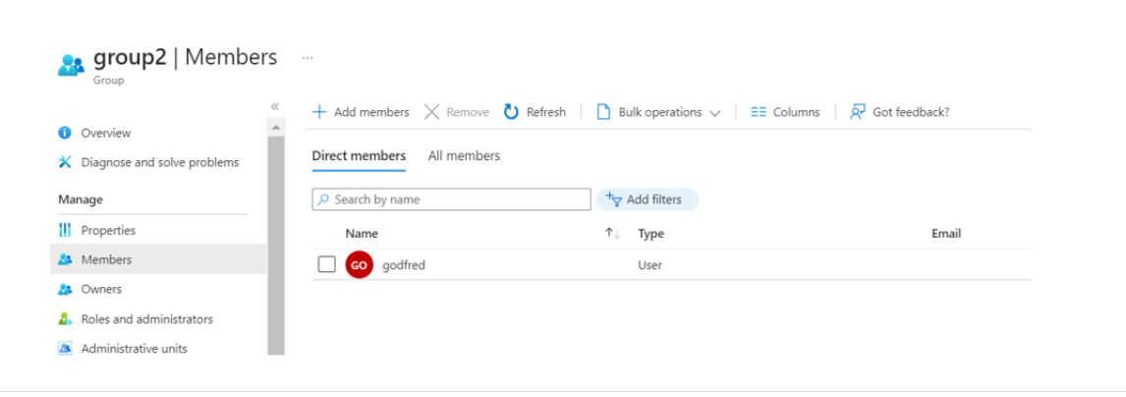

You need to identify Which Azure AD objects can be administered by Admin of administrative unit.

A. Chris Green, john, group2

B. Godfred, Chris Green, John

C. Group2 only

**292.** You have a virtual machine, and Network Security Groups (NSGs) are configured at both the subnet level and NIC level. For inbound traffic, which NSG will be evaluated first?

A. NIC Level

B. Subnet Level

**293.** You have an Azure virtual machine (Prod-VM01). You received a notification that prod-vm01 will be affected by maintenance.You need to move prod-vm01 to a different host immediately.

**Solution:** From the Redeploy+reapply blade, you click Redeploy.

Does this meet the goal?

Yes/No

**294.** Let's examine the following situation :.

The resource group includes:

* Virtual Machine A
* Storage account B
* Virtual network C

You are trying to deploy the below resource using the ARM template:

* Network security group D

Below is the PowerShell cmdlet you are using to deploy the template.

New-AzResourceGroupDeployment -Mode Complete -Name ExampleDeployment

-ResourceGroupName ExampleResourceGroup

-TemplateFile c:\MyTemplates\storage.json

As you can see in the above cmdlet, we are using mode as complete. When deploying resources with Azure Resource Manager templates (ARM templates), you have two options for deployment mode: incremental or complete. What will happen if we use mode as complete?

A. Resource Manager deletes resources in the resource group that aren't specified in the

template. - that means virtual machine A, Storage account B, Virtual Network C will be

deleted since these are not defined in ARM template.

B. The Resource Manager leaves unchanged resources in the resource group that aren't

defined in the template - that means virtual machine A, Storage account B, Virtual Network

C will not be deleted.

**295.** You have an Azure subscription that contains a resource group named Prod-RG1 in the West Europe location.

Prod-RG1 contains the resources shown in the following table:

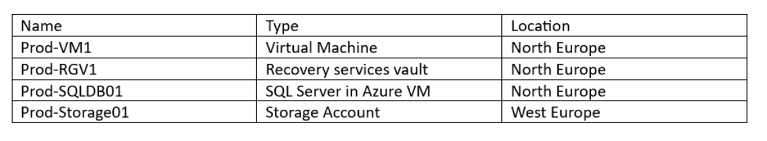

Prod-SQLDB01 is a backup to Prod-RGV1.

This entire setup was part of a testing project. Your testing is done, and you are trying to delete the

resource group, Prod-RG1, but deletion fails.

What should you do first?

A. Delete Prod-VM1

B. Stop Prod-VM1

C. Stop the backup of Prod-SQLDB01

D. Delete Prod-Storage01

**296.**  You have an Azure subscription, and there are 100 virtual machines in your subscription. You need to identify the underutilized VMs so that the service tier of those VMs can be changed to a less expensive offering.

Which Azure service will you use?

A. Monitor

B. Metrics

C. Advisor

**297.** What is the primary purpose of the Export-AzResourceGroup cmdlet in Azure PowerShell?

A. To export Azure resources from a resource group to a template file.

B. To import Azure resources into a resource group.

C. To list all the resources within an Azure resource group.

D. To delete all resources within an Azure resource group.

**298.** Apply the below tag to the resource group - EngineerBlog. Which PowerShell cmdlet will you choose to apply the tag to the resource group?

$tags=@{Name="CostCenter"; Value="0001"}

A. Set-AzResource -Name "EngineerBlog" -Tag $tags

B. Set-AzResourceGroup -Name "EngineerBlog" -Tag $tags

C. Get-AzResourceGroup -Tag $tags

**299.** You are a global administrator in an Azure AD tenant responsible for managing user access to Azure resources. You need to invite an external partner to collaborate on a project in your Azure environment, but you are encountering an error: unable to invite a user. a generic authorization exception when trying to invite guest users.

What should you check to resolve this problem?

A. Reset your Azure AD administrator password.

B. Verify that external collaboration settings allow guest invitations.

C. Ensure that the external partner's email address is correct.

**300.** You want to implement Azure file share on your on-premises Windows server. What is the recommended Windows OS required?

A. Windows server 2019 and above.

B. Windows server 2012

C. Windows server 2016

**301.** You have two Azure virtual networks (VNet-A and VNet-B) connected via a virtual network peering configuration. You want resources in VNet-A to resolve Fully Qualified Domain Names (FQDNs) of resources in VNet-B. What Azure service can you use to achieve this?

A. Azure DNS Private Zones

B. Azure Traffic Manager

C. Azure Load Balancer

D. Azure Bastion

**302.** Which network watcher tool allows you to measure latency between Azure and on-premises resources?

1. NSG diagnostics.
2. IP Flow verify.
3. Connection Monitor
4. VPN troubleshoot.

**303.** We need to upload a blob to a storage account (Prod-storage01). You have created the storage context

using the below PowerShell command.

$Storage = "Prod-storage01"

$Container = container1.

$Context =New-AzStorageContext -StorageAccountName $Storage -UseConnectedAccount

We need to upload a BLOB to a container. Which PowerShell cmdlet allows you to upload a Blob to acontainer?

________-Container $Container -File "Prod-RG1.json" -Blob "Prod-RG1.json" -context $Context -

StandardBlobTier Hot

A. Get-AzStorageAccount

B. New-AzStorageContext

C. Set-AzStorageBlobContent

**304.** In your Azure subscription, there is a highly important resource group named "Prod-rg1." The subscription owner intends to prevent the deletion of the resource group itself or any resources contained within it.

Which solution would you recommend. You also want to use a minimal amount of administrative effort.

A. Add a delete lock on individual resources inside the resource group.

B. Add a delete lock on the resource group.

C. Add a read-only lock on the subscription level.

**305.** A storage account is "serverless storage" to store data. You can access the data without running a VM from the internet and/or VMs in Azure. Can we also access data on the data disk if the disk is not attached to the VM?

Yes/No

**306.** You have an Azure Key Vault in your subscription. You executed the below powershell cmdlet:

$vault = Get-AzKeyVault -ResourceGroupName 'myrg1'

Below is the output of the cmdlet:

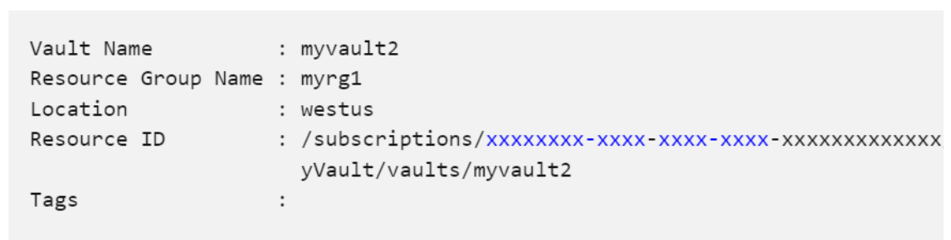

How would you retrieve only the resource ID property of the above-executed cmdlet?

A. $vault{ResourceID}

B. $vault.VaultName

C. $vault.ResourceID

**307.** You have an existing virtual machine (VM) in Azure, and you want to add it to an availability set for high availability. What is the correct approach to achieving this?

A. Migrate VM to another Azure Region.

B. Use the Azure Portal to move the existing VM directly into the availability set.

C. You cannot add an existing VM to an availability set; you must create a new VM within the set.

**308.** Which log tracks all control-plane operations that occur within the subscription, like stopping or restarting a virtual machine?

A. Azure AD Logs

B. Metrics Logs

C. Activity Logs

**309.** Your organization has hired a new cloud engineer and he should be able to manage cloud engineer's access as well. You also need to follow Microsoft principle of least privilege.

Which role should be assigned to cloud engineer ?

A. User Access Administrator

B. Owner

C. User Administrator

D. Contributor

**310.** You are planning to create a virtual machine scale set (VMSS) that has the following settings:

* Resource group name: RG1
* Region: West US
* Orchestration Mode: uniform
* Security type: Standard
* OS disk type: SSD standard

You need to add custom virtual machines to VMSS.

Which settings do you need to modify?

A. Security Type

B. OS disk Type

C. Orchestration Mode

**311.** You are executing the below PowerShell cmdlet to enable encryption.

$RGName = "MyResourceGroup"

$VMName ="MyTestVM"

$VaultName= "MyKeyVault"

$KeyVault = Get-AzKeyVault -VaultName $VaultName -ResourceGroupName $RGName

$DiskEncryptionKeyVaultUrl =$KeyVault.VaultUri

$KeyVaultResourceld = $KeyVault.Resourceld

$VolumeType ="All"

Set-AzVMDiskEncryptionExtension -ResourceGroupName $RGName -VMName $VMName -

DiskEncryptionKeyVaultUrl $DiskEncryptionKeyVaultUrl -DiskEncryptionKeyVaultld $KeyVaultResourceld -

VolumeType $VolumeType

It is required to stop the VM first before enabling encryption?

True/False

**312.** Which agent will replace the old log analytics agent for Windows and Linux machines?

A. Data collection Agent

B. Azure Monitor agent (AMA)

C. Azure cloud Sync

**313.** A company is looking to amend its security policy to enhance security by reducing the exposure of certain ports-3389 and 22-on its Azure virtual machines (VMs). They want to achieve this while maintaining secure remote access options. Which Azure service can help them achieve this goal?

A. Azure Bastion

B. Azure VPN Gateway

C. Azure Firewall

D. Azure Application Gateway

**314.** You have an Azure subscription, and below is the hub and spoke topology given.

HUB-VNET is connected to on-premises using a site-to-site VPN, and SPOKE-VNET is peering into HUB-VNET.

How VM1 can communicate with On-premises using the same HUB-VNET virtual network gateway.

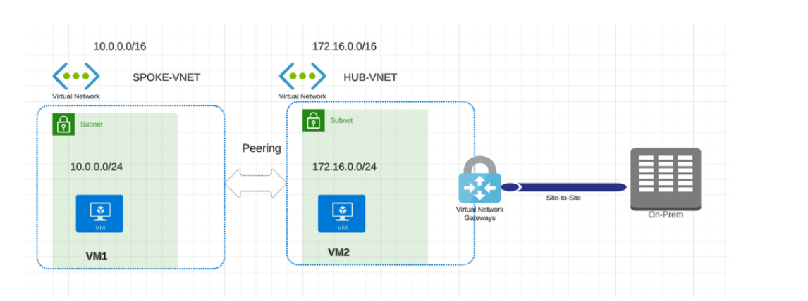

Select yes if the statement is true. Otherwise, select no.

**Statement:** You are planning to use Gateway Transit.

Yes/No

**315.** You have below Azure VM in your subscription.

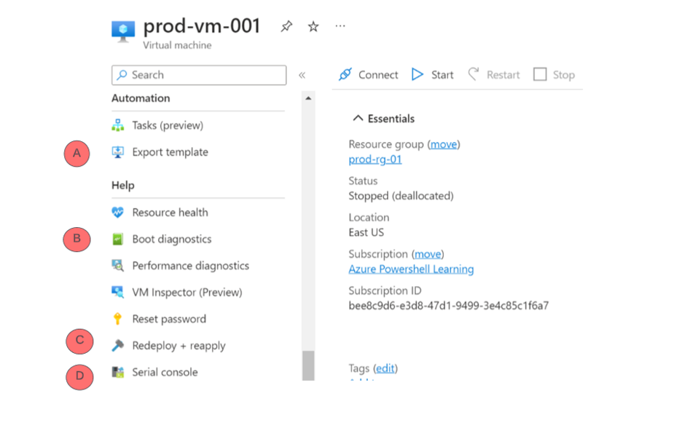

You need to create 10 more VMs based on the same configuration. Which blade will you use so that you can use the existing ARM template and modify it according to your requirements?

A. B

B. A

C. D

D. C

**316.** How can you successfully delete an Azure Recovery Services Vault that currently protects VM1 and VM2,given that you no longer need to maintain backups for these virtual machines and you are encountering error messages during the deletion process? Which three actions should you perform to delete the Azure recovery services vault?

a. Delete VM1 and VM2.

b. Stop the backup of VM1 and VM2.

c. Disable the soft delete feature and delete all the data.

d. Permanently remove any items in the soft delete state.

e. Delete the backup policy.

A. b,c,d

B. a,e,d

C. b,d,e

D. a,b,c

**317.** You have the below NSG configured in your Azure environment.

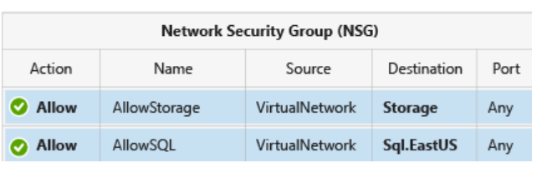

At the destination, we are directly providing the names of the services. What are these called?

A. Private endpoints

B. VNET

C. Service tags

D. Network rules